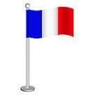

**Physical Education**

**Multi-skills (Spring 1) & Swimming (Spring 2 – dependent on restrictions**

National Curriculum Links

Pupils should be taught to:

Use running, jumping, throwing and catching in isolation and in combination

Play competitive games, modified where appropriate, and apply basic principles suitable for attacking and defending

Swim competently, confidently and proficiently over a distance of at least 25 metres

Use a range of strokes effectively

**Geography**

**The United Kingdom (including Northumberland):**

National Curriculum Links

Pupils should be taught about:

Name and locate counties and cities of the United Kingdom, geographical regions and their identifying human and physical characteristics

Understand geographical similarities and differences through the study of human and physical geography of a region of the United Kingdom

Use maps, atlases, globes and digital/computer mapping to locate countries and describe features studied

Use the eight points of a compass

**Learning Outcomes:**

Children will be able to:

Show how the UK is divided up into four countries

Recall the names of capital cities

Use maps of varied scales, locating the UK and Northumberland

Explain how the UK is further divided into regions

Research particular locations: London, Edinburgh, Northumberland

Make comparisons between different parts of the UK

Explore the concept of ‘topology’ across the UK and Northumberland

Explore the concept of ‘coastlines’ across the UK and Northumberland

**Music**

**Glockenspiel Stage 1 (Y3), Glockenspiel Stage 2 (Y4)**

National Curriculum Links

Pupils should be taught to:

Play and perform in solo and ensemble contexts, using their voices and playing musical instruments with increasing accuracy, fluency, control and expression

Improvise and compose music for a range of purposes

Listen with attention to detail and recall sounds



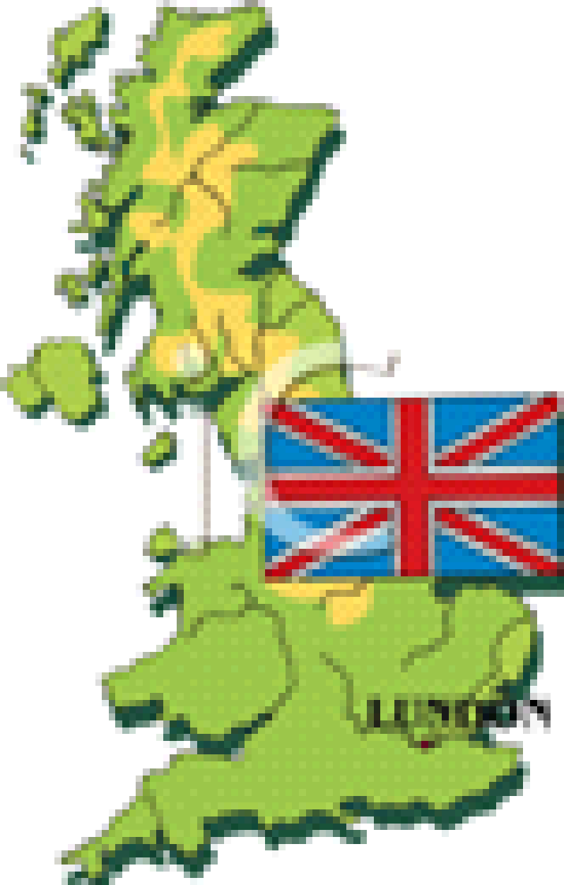

**Willow Class**

**Our United Kingdom**



**Topic-Based English**

**Stories with Environmental Issues**

**Persuasive Texts**

**Northumberland Folk Tales**

National Curriculum Links

Pupils should be taught to:

Develop positive attitudes to reading and understanding of what they read by increasing their familiarity with a range of books and text types

Identify themes and conventions in a range of books

Plan, draft, write, evaluate and edit their written work

Read aloud their own writing, using appropriate intonation and controlling the tone and volume so that the meaning is clear

Increase the legibility, consistency and quality of their handwriting

**PSHE**

**Respecting our environment**

National Curriculum Links

Pupils should be taught to:

Understand the impact that humans can have on the environment

Why we should look after our environment – P4C

Explore what can be done to protect our environment

**Maths**

National Curriculum Links: Year 3 *(Chestnut and Willow)*

Multiplication and Division Facts

Pupils should be taught to:

Recall and use multiplication and division facts for the 3, 4 and 8 multiplication tables

Write and calculate mathematical statements for multiplication and division, including for two-digit numbers times one-digit numbers, using mental methods and progressing to formal written methods

Measure (Money)

Pupils should be taught to:

Add and subtract amounts of money to give change, using both £ and p in practical contexts.

Statistics and Fractions

Pupils should be taught to:

Interpret and present data using bar charts, pictograms and tables

Answer one-step and two-step questions using information presented in scaled bar charts, pictograms and tables

Length and Perimeter

Pupils should be taught to:

Measure, compare, add and subtract: lengths (m/cm/mm); mass (kg/g); volume/capacity (l/ml)

Measure the perimeter of simple 2D shapes.

Fractions

Pupils should be taught to:

Count up and down in tenths; recognise that tenths arise from dividing an object into 10 equal parts and in dividing one-digit numbers or quantities by 10

Recognise and use fractions as numbers: unit fractions and non-unit fractions with small denominators

Recognise, find and write fractions of a discrete set of objects: unit fractions and non-unit fractions with small denominators

Solve problems that involve all of the above

**COVID Catch Up (CC) - Standalone Work**

**(Discovery RE)**

**Judaism**

**Learning Outcomes:**

**Children will be able to:**

Explain why agreements are important and why they should be kept.

Begin to understand the roles of Abraham and Moses and say why they are important to Jews today.

Explain the significance of one thing Jews do and say how it shows their significance with God.

P4C: How special is the relationship Jews have with God?

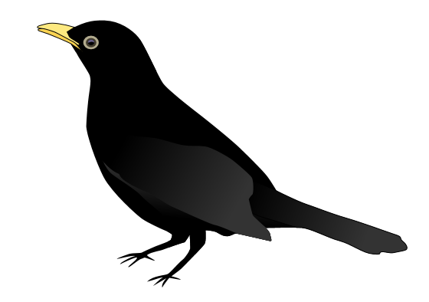

**Computing**

**Designing a computer game and controller**

National Curriculum Links:

Pupils should be taught to:

Design, write and debug programs that accomplish specific goals, including controlling or simulating physical systems

Solve problems by decomposing them into smaller parts

**Learning Outcomes**

Children will be able to:

Design, write and debug programs that accomplish specific goals, including controlling or simulating physical systems; solve problems by decomposing them into smaller parts

Use sequence, selection, and repetition in programs; work with variables and various forms of input and output

Use logical reasoning to explain how some simple algorithms work and to detect and correct errors in algorithms and programs

**Mastering English**

**Learning Outcomes**

Children will be able to:

Develop written responses to science based enquiry questions

Write a set of instructions about how to create an insect box

**Mastering Mathematics**

**Learning Outcomes**

Children will be able to:

Measure accurately to create an insect box

Collect and present data collected about animals found in the school environment

**Outdoor Learning Opportunities:**

**Geography**

Children will explore the human and physical features of Northumberland in a local context

**Science**

Children will identify local habitats in the school grounds and identify and classify living things living there.

**Science**

**Living things and their habitats**

National Curriculum Links

Pupils should be taught to:

Recognise that living things can be grouped in a variety of ways

Explore and use classification keys to help group, identify and name a variety of living things in their local and wider environment

Recognise that environments can change and that this can sometimes pose dangers to living things

Construct and interpret a variety of food chains, identifying producers, predators and prey

**Learning Outcomes:**

Children will be able to:

Understand what a habitat is and name ones that they can find locally

Sort animals into groups

Understand what animals need to survive

Use a key to identify animals

Describe what particular animals eat and where they get their food from

Give examples of how changes to habitats can affect animals

Give an example of a food chain in a particular habitat