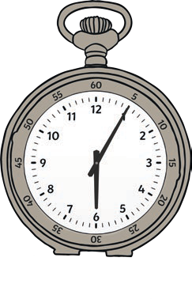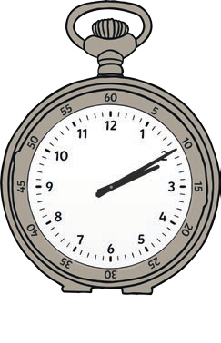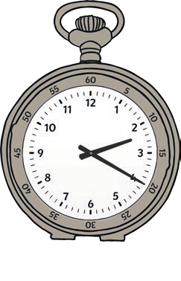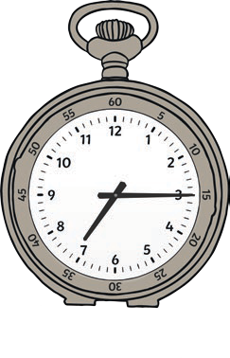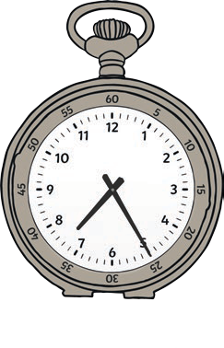
1.
2.
3.
4.
5.
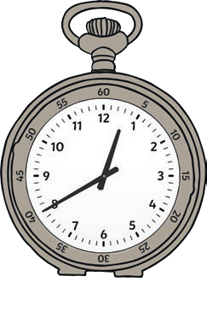
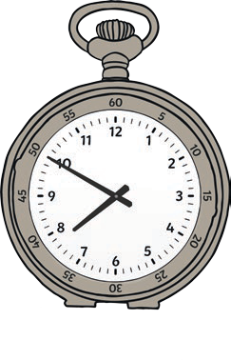
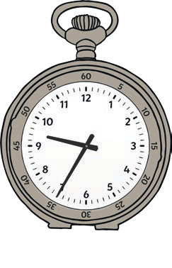
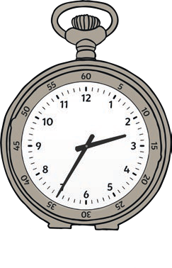
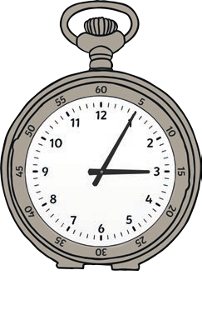
6.
7.
8.
9.
10.

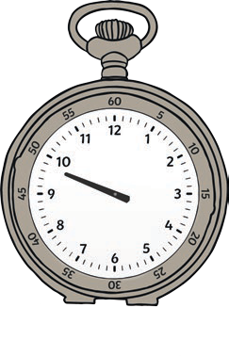
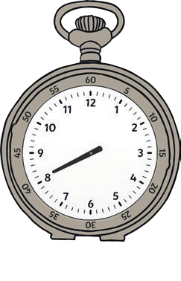
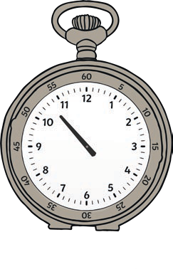
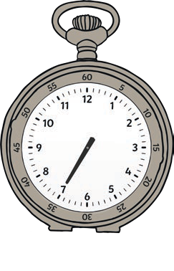
The hands of the professor’s pocket watch have fallen off! Draw them on so he knows what time it is.
11.
12.
13.
14.

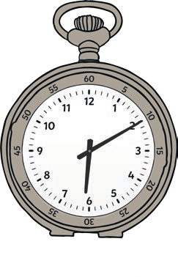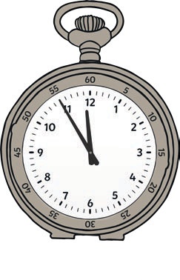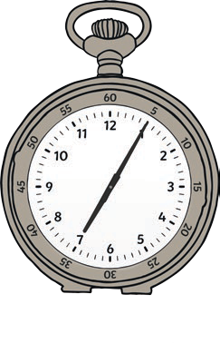
1.
2.
3.
4.
5.
6.
7.
8.
9.
10.

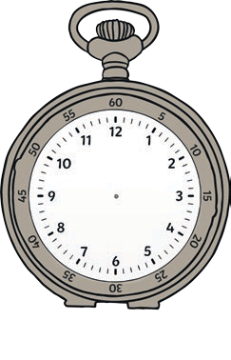
The hands of the professor’s pocket watch have fallen off! Draw them on so he knows what time it is.
11.
12.
13.
14.

Extensive Activity
Professor Pike’s pocket watch never tells the correct time! Write down what the watch says if the real time was: 20 minutes to 10
- 5 minutes slow

- 15 minutes fast

- 10 minutes slow

- 20 minutes fast

- 15 minutes slow

- 25 minutes fast

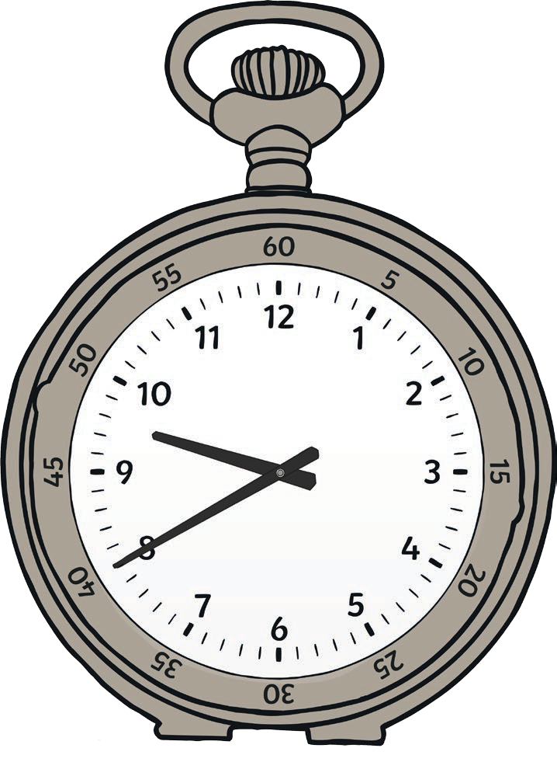

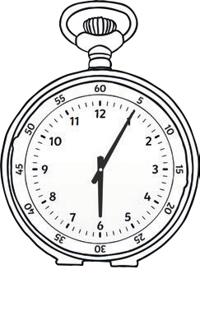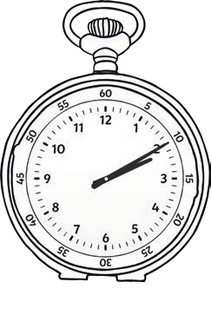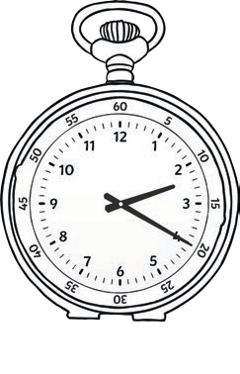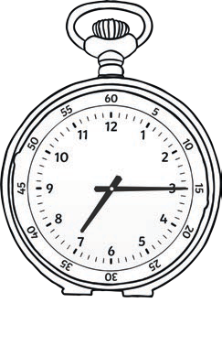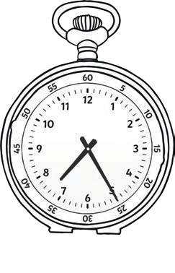
1.
6:05
2.
2:10
3.
2:20
4.
7:15
5.
7:25

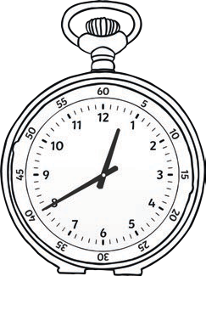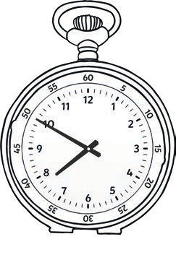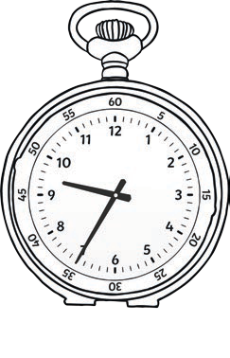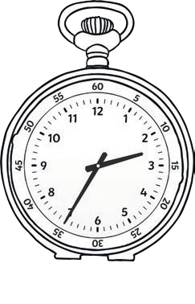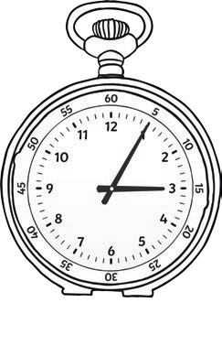
6.
12:40
7.
7:50
8.
9:35
9.
2:35
10.
3:05
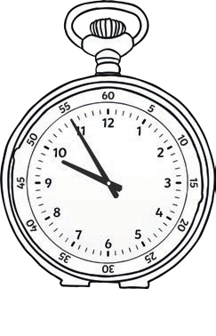
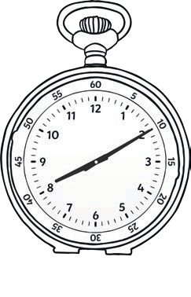
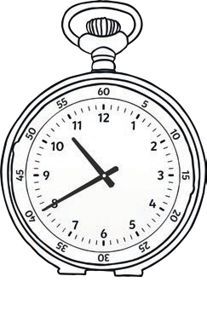
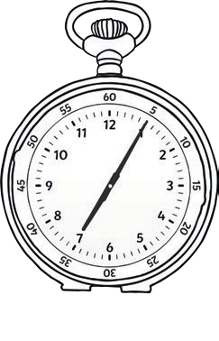
The hands of the professor’s pocket watch have fallen off! Draw them on so he knows what time it is.
11.
12.
13.
14.

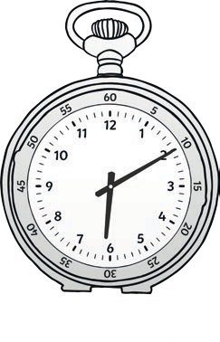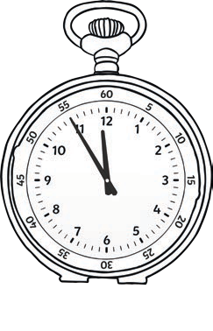
1.
6:10
2.
11:55
3.
2:20
4.
7:15
5.
7:05

6.
12:40
7.
7:50
8.
9:35
9.
2:35
10.
3:05
The hands of the professor’s pocket watch have fallen off! Draw them on so he knows what time it is.
11.
12.
13.
14.

Extensive Activity
Professor Pike’s pocket watch never tells the correct time! Write down what the watch says if the real time was: 20 minutes to 10
- 5 minutes slow

- 15 minutes fast

- 10 minutes slow

- 20 minutes fast

- 15 minutes slow

- 25 minutes fast


