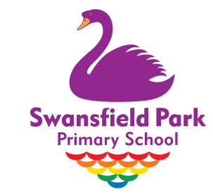

Dear Parents / Carers,
PE Sessions for First Half of Spring Term
Please find below details of the school based PE lessons for the Spring Term, which will start on Thursday 6th January.
Class | PE Activity | Day
Pear | Teacher led PE session | Thursday morning
Plum (Reception and Year 1)  PLUM - YEAR 1 ONLY | Teacher led PE session  Team Games with Newcastle United Foundation. | Thursday morning  Tuesday morning
Ash | Teacher led PE session  Team Games with Newcastle United Foundation. | Monday afternoon  Tuesday morning
Beech | Teacher led PE session  Team Games with Newcastle United Foundation. | Wednesday afternoon  Tuesday morning
Oak | Teacher led PE session  Team Games with Newcastle United Foundation. | Monday morning  Tuesday morning

In line with our Covid-19 Risk Assessment, we are asking children to come into school in their PE kit on the day of their PE lesson(s). The required PE uniform is:
- white t-shirt (plain or school logo)
- plain, unbranded black leggings or tracksuit bottoms
- purple shorts
- school jumper, cardigan or purple logo hoodie
- plain black or white socks
- plain black or white trainers
If you have any further questions or queries, please do not hesitate to contact your child’s class teacher.

