Oak Class News
Summer Term 1&2 2023
amy.smith2@school360.co.uk
www.swansfield.northumberland.sch.uk

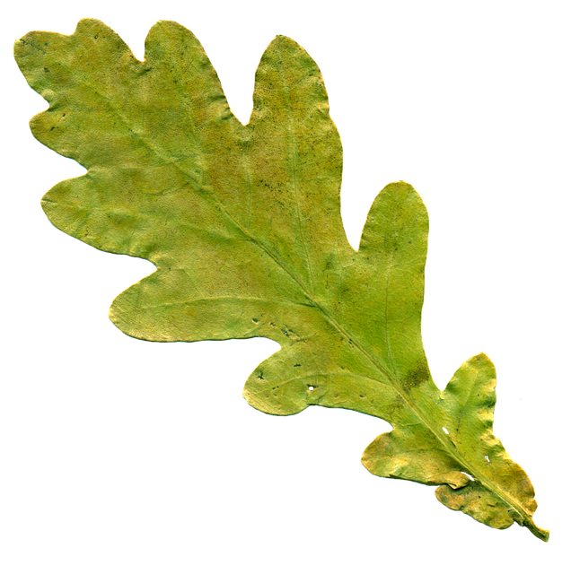

Our topic for this term is…
Oak Class are planning a trip to the beach in the second half of the summer term-details to follow in the coming weeks.
Beside the Seaside
Geography
The children will learn the vocabulary associated with the seaside area eg sea, beach, coast, cliff, river, ocean. They will visit the beach and make observational drawings of the landscape as well as look at aerial photographs of coastal areas. They will learn the names of oceans and find out about the role of local harbours.
Science
The children will name and sort different materials, learning about their different properties and uses. Our beach visit will provide an opportunity to compare animal habitats and draw food chains. In addition we will take advantage of the new growing season by planting seeds and monitoring their progress as they grow.
Art
The children will develop their painting techniques by painting floral pictures to enter in the annual Britain in Bloom contest as well as painting seascapes. The paintings of local artist Mick Oxley and British artist Robert Talbot will provide a stimulus for this. We will use the abundance of natural objects on the beach to help create natural sculptures and to support this we will look at the work of sand artists Sudarsan Pattnaik and Jamie Wardley.
DT
The children will design and make their own sandwich for a seaside picnic. As part of this process they will taste different breads and sandwich fillings. They will learn about food safety and hygiene and techniques including spreading, cutting, chopping and peeling.
History
Holidays have changed over the last century. We will ask our older relatives and look at old photographs to see how holidays from the past compare to our own holidays today.
Computing
The children will use programs such as “Word”, “2Simple” and “Powerpoint” to edit text and download pictures. We will also program ‘Code-a-Pillar’ to follow directions through a sea themed route. They will use School360 to access tasks to support our curriculum in school and for homework.
RE
We will look at the Jewish community by finding out about Shabbat and other Jewish traditions.
PSHE
We will learn together about how to build positive, healthy relationships. We will also learn about how to cope positively with change and an important part of the end of term will be preparing the children for their change in class.
Music
The children will learn about pulse, rhythm and pitch listening to “Round and Round” in Bossa Nova style and also performance and improvisation through “Your Imagination” using the theme of musicals.

PE
Tuesday Striking & Fielding with NUF and a teacher led PE session on a Thursday.
English
Children in Oak will continue with the RWInc (RWI) phonics programme working in small groups to consolidate set 1 and 2 sounds and to learn set 3 sounds and reading and writing sentences. Children secure in all sounds will continue their English learning with a focus on developing their reading and comprehension skills, grammar and punctuation. English involves the development of speaking and listening, reading fluency, comprehension and writing skills. Children will have many opportunities to develop their reading and comprehension skills both in the classroom and during weekly guided reading sessions. They will also be able to apply their skills across other areas of the curriculum during their topic work. Over the course of the year, children will experience a range of narrative, non-fiction and poetry texts. This half term, we intend to use non-fiction and fiction related to the beach. Children are welcome to bring in books related to the topic.*
Mathematics:
In KS1, our aim is to ensure that pupils develop confidence and mental fluency with number, counting and place value. Our learning begins in a very practical way before moving to more formal methods. The children’s ability to ‘reason’ will be developed throughout all of their mathematical work as they are encouraged to explain how they have reached solutions to problems, especially related to measurement for example: length, height, mass, time.
This term, we will be focusing on money and fractions and measuring length, volume. Mass and time. We will also be continuing with the four number operations (addition, subtraction, multiplication and division.*
*You can find specific objectives for the half-term on your class page of the school website.
Homework & Spellings
Weekly tasks and spellings will be detailed in the Home Learning section of our class page on the school website.
Spellings: Spellings will be set and tested each Friday. Please encourage your child to practise these regularly – little and often is usually the most effective method for long-term learning.
Weekly Tasks: Each Friday, your child will be set a homework task to be completed before the following Friday. The children have their School360 usernames and passwords which they can use to access Busy Things.
Mental Maths: Times tables and number facts will be tested on a weekly basis. Please practise these regularly with your child at home. By the end of year two, children are expected to know the number facts for the 2, 5 and 10 times tables. The children have their Numbots usernames and passwords which can also be used to access Times Table Rockstars.
Reading: Please encourage your child to read their reading book (which is linked closely to their RWInc group) regularly with you at home. It helps us out enormously if you have written a comment or signed their reading record each week. In school, children will have a weekly guided reading session where they will read and discuss their book, so please send their reading books and reading records with them on Wednesdays and Thursdays.
In addition children now have their Oxford Owl passwords and they can access the ebooks for those they have read during RWInc sessions as well as a quiz for each book..
Additional items in school
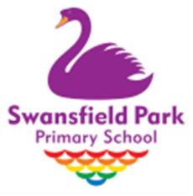
Please send a clean, named water bottle to school each day. Please do not send juice or flavoured water. Toys, collectable cards and gadgets should not be brought into school.
Uniform Please name everything!
If you have any questions please speak to me at the door or email me.

