# E:\Users\simon.roche\AppData\Local\Microsoft\Windows\Temporary Internet Files\Content.Word\Evidencing the Impact of the Primary PE and Sport Premium Template 2019 7.3 Images_Page_1.jpg

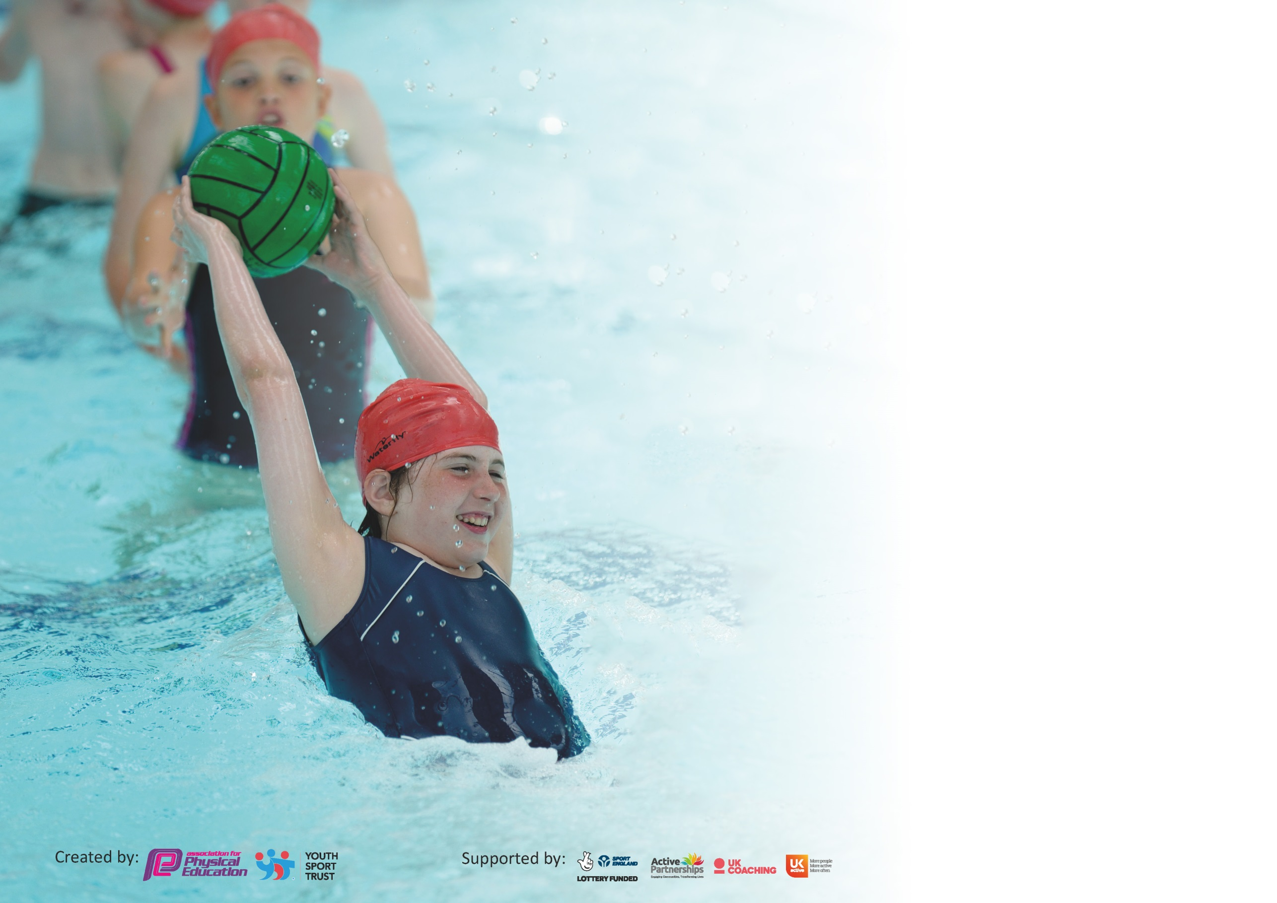

It is important that your grant is used effectively and based on school need. The [Education Inspection Framework](https://assets.publishing.service.gov.uk/government/uploads/system/uploads/attachment_data/file/843108/School_inspection_handbook_-_section_5.pdf) (Ofsted 2019 p64) makes clear there will be a focus on **‘whether leaders and those responsible for governors all understand their respective roles and perform these in a way that enhances the effectiveness of the school’**.

Under the [Quality of Education criteria](https://assets.publishing.service.gov.uk/government/uploads/system/uploads/attachment_data/file/843108/School_inspection_handbook_-_section_5.pdf) (p41) inspectors consider the extent to which schools can articulate their curriculum (INTENT), construct their curriculum (IMPLEMENTATION) and demonstrate the outcomes which result (IMPACT).

To assist schools with common transferable language this template has been developed to utilise the same three headings which should make your plans easily transferable between working documents.

Schools must use the funding to make **additional and sustainable** improvements to the quality of Physical Education, School Sport and Physical Activity (PESSPA) they offer. This means that you should

use the Primary PE and Sport Premium to:

* Develop or add to the PESSPA activities that your school already offer
* Build capacity and capability within the school to ensure that improvements made now will benefit pupils joining the school in future years

Please visit [gov.uk](https://www.gov.uk/guidance/pe-and-sport-premium-for-primary-schools) for the revised DfE guidance including the 5 key indicators across which schools should demonstrate an improvement. This document will help you to review your provision and to report your spend. DfE encourages schools to use this template as an effective way of meeting the reporting requirements of the Primary PE and Sport Premium.

We recommend you start by reflecting on the impact of current provision and reviewing the previous spend.

Schools are required to [publish details](https://www.gov.uk/guidance/what-maintained-schools-must-publish-online#pe-and-sport-premium-for-primary-schools) of how they spend this funding as well as on the impact it has on pupils’ PE and sport participation and attainment by the end of the summer term or by **31st July 2020** at the latest.

We recommend regularly updating the table and publishing it on your website throughout the year. This evidences your ongoing self-evaluation of how you are using the funding to secure maximum, sustainable impact. Final copy must be posted on your website by the end of the academic year and no later than the 31st July 2020. To see an example of how to complete the table please click [HERE](http://www.afpe.org.uk/physical-education/wp-content/uploads/afPE-Example-Template-Indicator-2018-Final.pdf).

Support for review and reflection - considering the 5 key indicators from DfE, what development needs are a priority for your setting and your pupils now and why? Use the space below to reflect on previous spend and key achievements and areas for development.

|  |  |
| --- | --- |
| Key achievements to date until July 2019: | Areas for further improvement and baseline evidence of need: |
| * All children in KS2 have one and a half terms worth of swimming lessons per academic year. * All children have two PE sessions per week. * All children in EYFS and KS1 have access to Forest School sessions. * Links to variety of external coaches established both in the commercial sector and through local sports clubs. * Increased opportunities for children in KS2 to access extra-curricular sports. * Enhanced programme of competitive sports in KS2. * Achieved Silver Sports Mark in 2018 / 2019. * Developing a programme of adventurous activities for KS2 children including Ford Castle residential for Year 4 and canoeing in Years 5 and 6. | * Further develop confidence and skills of class teachers in PE ensuring that all are able to provide high quality and physically demanding PE sessions.   • Broaden range of extra-curricular sports and activities offered to children across the school.  • Further develop opportunities for children to participate in competitive sports  • Target support in PE towards more vulnerable pupils and to those whose activity levels are lower  • Improve levels of physical activity during playtimes.   * Curriculum coverage reviewed and new structure established across school. * Further develop programme of adventurous activities. |

|  |  |
| --- | --- |
| Meeting national curriculum requirements for swimming and water safety. |  |
| What percentage of your current Year 6 cohort swim competently, confidently and proficiently over a distance of at least 25 metres?  **N.B.** Even though your pupils may swim in another year please report on their attainment on leaving  primary school at the end of the summer term 2020. | 83%\* |
| What percentage of your current Year 6 cohort use a range of strokes effectively [for example, front crawl, backstroke and breaststroke]? | 83%\* |
| What percentage of your current Year 6 cohort perform safe self-rescue in different water-based situations? | 83%\* |
| Schools can choose to use the Primary PE and Sport Premium to provide additional provision for swimming but this must be for activity **over and above** the national curriculum requirements. Have you used it in this way? | No |

**Action Plan and Budget Tracking**

Capture your intended annual spend against the 5 key indicators. Clarify the success criteria and evidence of impact that you intend to measure to evaluate for pupils today and for the future.

|  |  |  |  |  |
| --- | --- | --- | --- | --- |
| **Academic Year:** 2019/20 | **Total fund allocated:** £18,700 | **Date Updated: 22th May 2020** | |  |
| **Key indicator 1:** The engagement of all pupils in regular physical activity – Chief Medical Officer guidelines recommend that primary school pupils undertake at least 30 minutes of physical activity a day in school | | | | Percentage of total allocation: |
| % |
| **Intent** | **Implementation** | | **Impact** | 6 |
| Your school focus should be clear what you want the pupils to know and be able to do and about  what they need to learn and to  consolidate through practice: | Make sure your actions to achieve are linked to your intentions: | Funding allocated: | Evidence of impact: what do pupils now know and what can they now do? What has changed?: | Sustainability and suggested next steps: |
| * Increased levels of fitness and activity. * Greater engagement in physical activity amongst children. * Greater structure to play activities in playground | * New playground equipment purchased to ensure that children have access to high quality resources during break and lunchtimes that encourage physical activity. * Year 5 Sports and Playground leaders trained to support and encourage children to participate in games at break and lunch times. | £1020 – PE and playground equipment | * Levels of activity amongst children at lunchtime has increased. This was sustained across the Autumn and Spring terms. * Pupil voice with Year 4 buddies has shown that most of the play equipment is being used at break and lunchtime. * PE Playground and Sports Leaders from Y5 have supported lunchtime staff and encouraged younger children to participate in physical activity. | * Introduce Specific observations of lunchtimes to reveal the activity of children. * Pupil voice with school council to gather the opinions of the children about how we can encourage children to be more active at lunchtime. * Implement more structured games into lunchtimes. * Research and implement a Swansfield Daily Mile approach to daily physical activity. * Sports Leaders and Playground Leaders to be given hoodies to raise their profile on the yard / field. |
| **Key indicator 2:** The profile of PESSPA being raised across the school as a tool for whole school improvement | | | | Percentage of total allocation: |
| 0% |
| **Intent** | **Implementation** | | **Impact** | 0 |
| Your school focus should be clear what you want the pupils to know and be able to do and about  what they need to learn and to  consolidate through practice: | Make sure your actions to achieve are linked to your intentions: | Funding allocated: | Evidence of impact: what do pupils now know and what can they now do? What has changed?: | Sustainability and suggested next steps: |
| * PE and Sport coordinator to oversee and coordinate whole school approach to PE and Sport. * PE skills progression grid to be completed and shared with staff and coaches for use within lessons.   • Increased profile for PE and Sport around school | * PE coordinator to attend partnership PE meetings. * PE coordinator to source new coaches and opportunities for children. * Staff meeting held to focus on the progression of skills, assessment, and teaching within PE sessions. * Release time for PE CPD / Coaching & Mentoring / Learning Walk. * Regular announcements via Parent Mail of PE events, clubs and achievements shared in the half termly newsletter. * PE notice board outside of Chestnut class updated on a regular basis. | £0 | * PE noticeboard maintained throughout the year. Children have enjoyed looking at this. * Although staff meeting was not held, skills progression grid were shared with staff for use in lessons to ensure consistency across the school. * New coaches booked for the next academic year. PE sessions will focus on the teaching of specific skills. * Documents and information from meetings shared with staff. | * Develop more effective communication system for details of PE and Sports around school to ensure all relevant parents are aware of opportunities. * Fully implement the use of the PE skills progression grids. * Evaluate the impact of securing new coaches on uptake of extracurricular clubs. |

|  |  |  |  |  |
| --- | --- | --- | --- | --- |
| **Key indicator 3:** Increased confidence, knowledge and skills of all staff in teaching PE and sport | | | | Percentage of total allocation: |
| % |
| **Intent** | **Implementation** | | **Impact** | 20 |
| Your school focus should be clear | Make sure your actions to | Funding | Evidence of impact: what do | Sustainability and suggested |
| what you want the pupils to know | achieve are linked to your | allocated: | pupils now know and what | next steps: |
| and be able to do and about | intentions: |  | can they now do? What has |  |
| what they need to learn and to |  |  | changed?: |  |
| consolidate through practice: |  |  |  |  |
| * Greater variety of activities experienced within lessons.   • Level of challenge in sessions increased.   * PE coordinator to attend partnership PE meetings and relevant CPD courses. The outcomes can then be shared with staff. * Staff to lead after school clubs. | * Teaching assistant timetabled to work with coaches to increase capacity of knowledge and skills across school. * Release time for PE CPD / Coaching & Mentoring. * Review UKS2 curriculum to ensure that children have access to a wider variety of experiences and have sufficient challenge within lessons. | £500 – whole school CPD  £3300 – member of staff employed to assist with the delivery of high-quality teaching. | * Afterschool Netball club and Football training established and well attended by pupils in UKS2. * Member of staff able to offer support and guidance to class teachers in UKS2 PE due to involvement with sports coaches on a Tuesday. This has led to increased challenge in lessons. * Children have access to high-quality, competitive, age appropriate sports which prepares them for the next stage in their learning. | * More focussed teaching and development of key skills during PE lessons. * More staff to lead after school PE clubs, with support from sports coaches. * Review curriculum offer to LSK2 and KS1 to ensure that the variety of activities matches that in UKS2. * Review curriculum offer in particular outdoor and adventurous activities across the school * Organise relevant CPD sessions for all staff with Newcastle Foundation. * PE coordination to increase the profile and and accountability for physical education, sports participation and financial accountability |
| **Key indicator 4:** Broader experience of a range of sports and activities offered to all pupils | | | | Percentage of total allocation: |
| % |
| **Intent** | **Implementation** | | **Impact** | 58 |
| Your school focus should be clear | Make sure your actions to | Funding | Evidence of impact: what do | Sustainability and suggested |
| what you want the pupils to know | achieve are linked to your | allocated: | pupils now know and what | next steps: |
| and be able to do and about | intentions: |  | can they now do? What has |  |
| what they need to learn and to |  |  | changed?: |  |
| consolidate through practice: |  |  |  |  |
| * Greater variety of activities experienced within lessons * Bikeability to be offered to Year 5 pupils again this year – aim for all pupils to achieve their expected level again this year. * To integrate adventurous sports into the KS2 curriculum. * All children in KS2 to have access to age appropriate, competitive sports. | * Release time for PE CPD / Coaching & Mentoring / learning walks. * Employ high quality, specialised coaches for at least 1 PE lesson per week for each class. * Specialised sports coaches to run after extra-curricular clubs for children from Reception to Year 6. | £3000 - PE Facilities Rental  £1840 - KS2 Bikeability  £4900 - Sports Coaches  £1140 – contribution to adventurous sports in KS2. | * All children in KS1 and KS2 accessed at least 1 lesson per week taught by a specialised sports coach, meaning that their learning and progress was accelerated in those lessons. * Number of extra-curricular clubs offered to the children has increased this year. * It was decided that some clubs i.e. gymnastics should be split into Key Stage groups. The uptake of this was higher as a result of this decision. It also meant that each session could focus on the age appropriate skills. * Some children (year 5) completed their Level 1 and 2 Bikeability course, meaning they now have the skills and knowledge to be safe on the roads. (Not all children completed the course due to Covid -19 closure). * All children in UKS2 made use of the facilities offered at Lindisfarne Middle School. This meant that they could play age-appropriate, competitive sports. * To ensure that all children, especially those in KS2 could access age – appropriate competitive sports, new equipment was purchased. * Children in UKS2 took part in a canoeing day on the River Coquet in September 2019. * The whole school took part in Judo sessions with a local coach who is now offering a Judo club run in school. | * More focussed development of key skills in PE lessons using Newcastle Foundation coaches. * Support provided for children who might be struggling with aspects of PE or for those excelling * To find opportunities for rock climbing, archery and fencing. Staff keen to be able to develop their CPD in these areas too. * Investigate further how children who have not participated might be encouraged to try a sports club. * Continue to improve targeting of clubs on vulnerable children and those years groups with lower take up of clubs * To fully integrate adventurous sports into the KS2 curriculum. |

|  |  |  |  |  |
| --- | --- | --- | --- | --- |
| **Key indicator 5:** Increased participation in competitive sport | | | | Percentage of total allocation: |
| % |
| **Intent** | **Implementation** | | **Impact** | 16 |
| Your school focus should be clear | Make sure your actions to | Funding | Evidence of impact: what do | Sustainability and suggested |
| what you want the pupils to know | achieve are linked to your | allocated: | pupils now know and what | next steps: |
| and be able to do and about | intentions: |  | can they now do? What has |  |
| what they need to learn and to |  |  | changed?: |  |
| consolidate through practice: |  |  |  |  |
| * Broaden opportunities for children to compete against other others   • Increased levels of resilience and self-confidence  • Greater engagement amongst children who have not previously taken part in sports competitions. | * Re-establish school football team and join the partnership league. * Join Northumberland School Games. * Attend as many sports competitions as possible. * Subsidise the cost of transport to competitions and football matches. * Purchase new kits to increase confidence. * Encourage the least active and SEN children to compete in competitions. * Hold two sports days to ensure that KS2 have access to age appropriate, competitive sporting activities. | £2000 - Transport to competitions and football matches.  £1000 – PE kits and competition team kits. | * Football team played competitive, age appropriate games in league. This however was cut short due to closure. * Swansfield attended several competitions run by School Games. Again, this was cut short due to closure. * Children in Year 5 were trained by Active Northumberland to help officiate games at the Year 3 and 4 Tag Rugby competition. * The least active and SEND children in Year 4 competed in a Multi-Skills competition. * The least active and SEND children in Year 5 competed in an Indoor Athletics competition. * Silver Sports Mark retained. | * Retain Silver Sports Mark. * Continue to encourage the least active and SEND children to attend competitions. * Review viability of continued subsidy to parents. * Develop further opportunities for competitive events such as intra-school events. * Focus on Healthy Lifestyles events for less competitive children. |

|  |  |
| --- | --- |
| Signed off by | |
| Head Teacher: |  |
| Date: | 1st June 2020 |
| Subject Leader: |  |
| Date: | 22nd May 2020 |
| Governor: |  |
| Date: |  |

\*Year 6 children did not finish their full course of swimming lessons due to Covid-19 school closure.

The implementation of this academic year’s PE Premium has been effected by the Covid-19 school closures.