If you can, print the page then count the frogs or count the frogs then say the number.
How many?

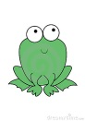How many?
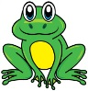How many?

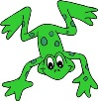How many?

Count the fish. If you can, print this page then count the fish and write the total or count the fish on the screen and say the number.
How many?
How many?
How many?
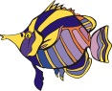 How many?
Now find some objects in your house to use to count. Count out these numbers:

37 18 59

23 41

68 52 80

Remember to keep your objects in groups of 10 to make it easier to count!

If your Mum or Dad could take a photo of you counting some of your objects and send them to me, I’d love to see you in counting action!

