My Favourite Places in Alnwick

The Alnwick Garden and Adventure Golf
Wobbly bridges at the treehouse
Splash around in the Serpent Garden
13 hole golf course
Smelling the roses in the summer
Learning about the poisonous plants
Swinging in the cherry orchard

Barter Books
Largest second hand book store
Delicious cakes and sandwiches
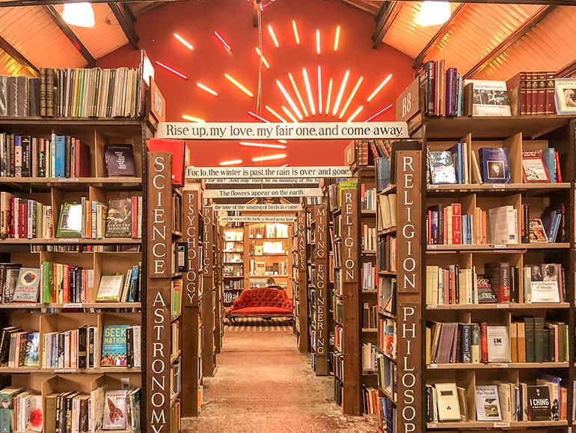
Sit down and relax next to the fire

Pets At Home
Sells everything you need for your pet including your pet!
Has a groom room
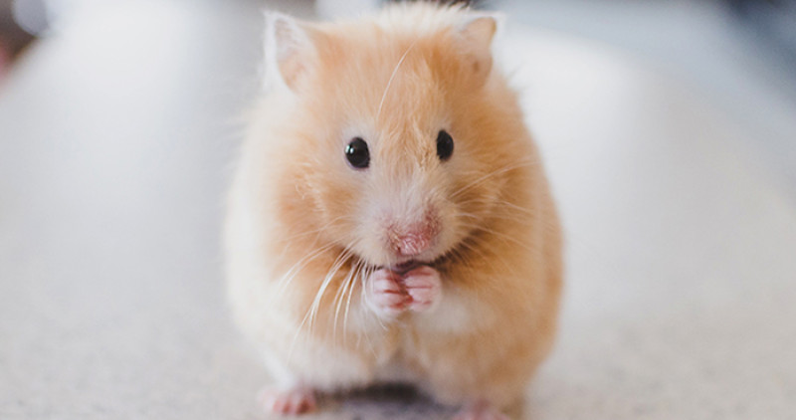
Friendly and helpful staff

