1 | 3 + 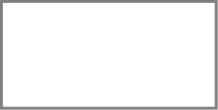 = 8 |  |  | 2 | 3 × 10 =
3 | 17 – = 9 |  |  | 4 | = 73 + 8
5 | 80 – = 50 |  |  | 6 | 8 + 7 + 2 =
7 | 3 7  + 3 1 |  |  | 8 | – 30 = 19
9 | 5 6  – 3 5 |  |  | 10 | 9 × 2 =

11 | 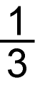 of 18 = |  |  | 12 | × 3 = 24
13 | 34 + = 71 |  |  | 14 | 6 5  + 2 7
15 | ÷ 2 = 40 |  |  | 16 | 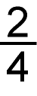 of 20 =
17 | 5 6  – 3 8 |  |  | 18 | = 40 × 5
Total marks/18

How well did you do?  Colour the numbers of the  questions you got correct. | ± without crossing a ten | 5 | 7 | 8 | 9
 | ± crossing a ten | 4 | 13 | 14 | 17
 | 2×, 5× and 10× tables | 2 | 10 | 15 | 16 | 18
 | 3× table | 2 | 11 | 12
 | Tables of multiples of 10 | 15 | 18
 | Fractions of an amount | 11 | 16
 | Missing number statements | 1 | 3 | 5 | 8 | 12 | 13 | 15
 | + | 4 | 6 | 7 | 8 | 14
 | – | 1 | 3 | 5 | 9 | 13 | 17
 | × | 2 | 10 | 12 | 15 | 16 | 18
 | ÷ | 11 | 12 | 16

