Wednesday 24th June
Writing Challenge
Read the questions and try to answer them. You can tell someone in your house the answers or write them down.
Who is Katie Morag?
Where does Katie Morag live?
What job does Katie Morag help to do?
What does Katie Morag look like?
What job does Katie Morag’s Grannie do?
What would you like to ask Katie Morag?
Write a sentence about each picture to tell the story. Words to help: Katie Morag, Grandma, deliver.

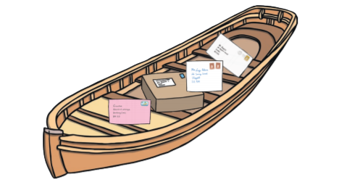

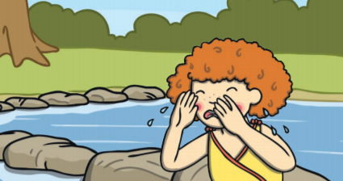

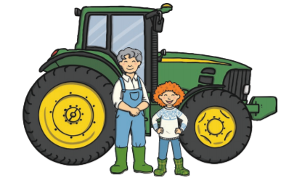

Remember to:
- Write neatly
- Leave finger spaces
- Use full stops and capital letters

