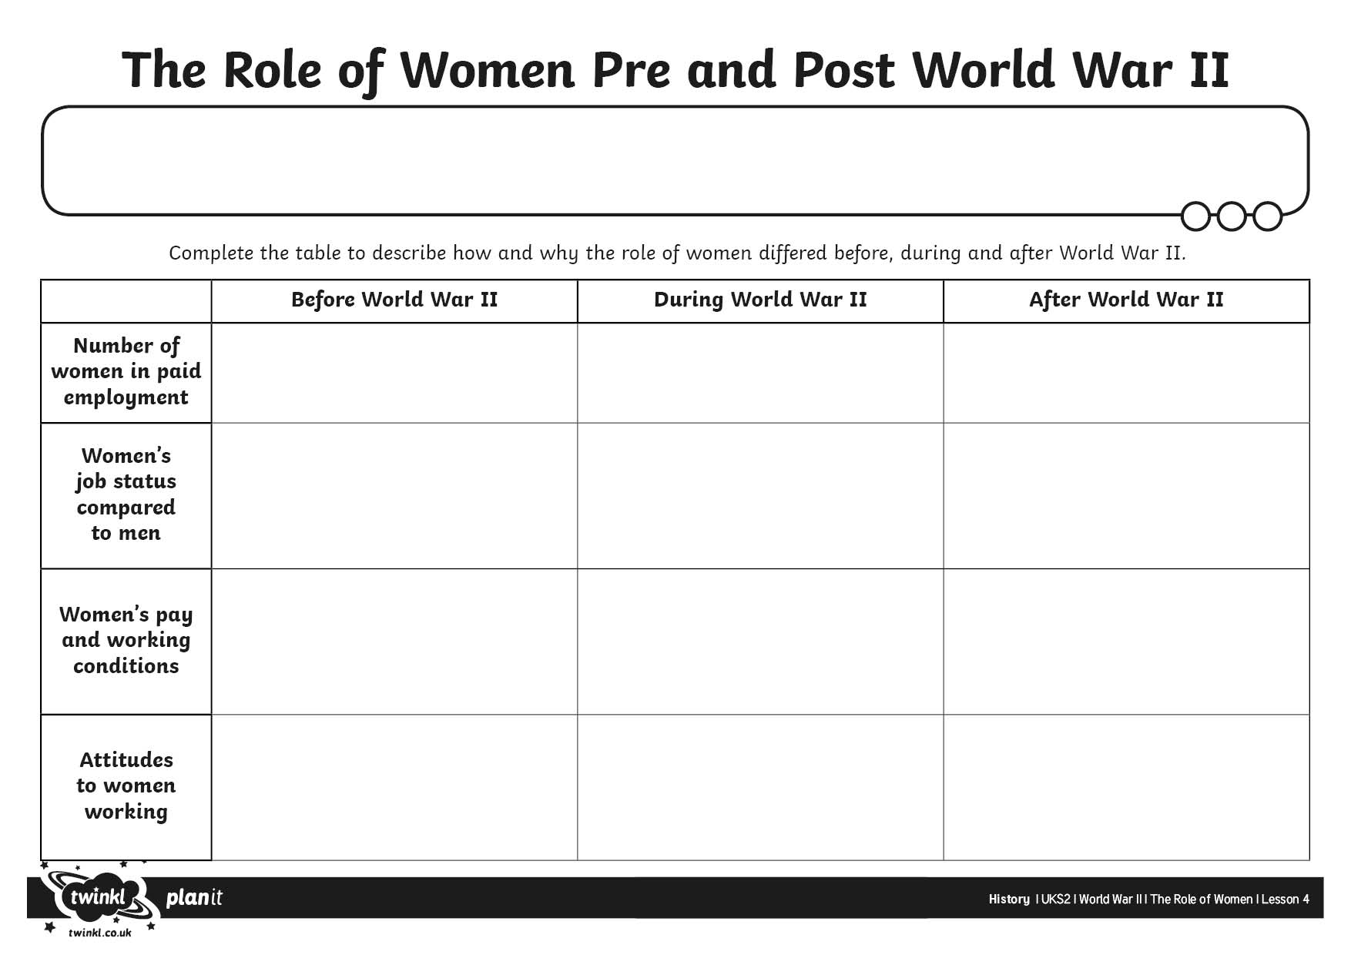

I can explain how the role of women differed before, during and after the war.