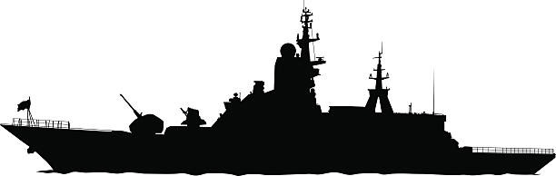
Battleships!

MY FLEET
8
7
6
5
4
3
2
1
 | 1 | 2 | 3 | 4 | 5 | 6 | 7 | 8
A | A | A | A | A

Aircaft carrier
B | B | B | B

Battleship
C | C | C

Crusier
D | D
D | D

Destroyers
S
S

Submarines

ENEMY FLEET
8
7
6
5
4
3
2
1
 | 1 | 2 | 3 | 4 | 5 | 6 | 7 | 8
A | A | A | A | A

Aircaft carrier
B | B | B | B

Battleship
C | C | C

Crusier
D | D
D | D

Destroyers
S
S

Submarines

