1 | 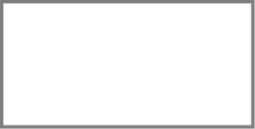 = 5 × 11 |  |  | 2 | 40 = 563 –
3 | 1 × 0 = |  |  | 4 | 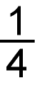 of 20 =
5 | 23 × 1 = |  |  | 6 | 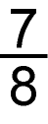 – 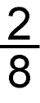 =
7 | = 2 × 9 × 5 |  |  | 8 | 4 × 9 =
9 | 2 3  + 3 8 |  |  | 10 | 298 + 8 =
11 | 19 ÷ 1 = |  |  | 12 | 8 0  – 3 3
13 | = 90 × 2 |  |  | 14 | 63 ÷ 9 =

15 | 6 4  + 7 7 |  |  | 16 | 2 6  × 4
17 | 83 – = 55 |  |  | 18 | 4 6  × 5
19 | $$3|\overline{\text{84}}$$ |  |  | 20 | × 2 = 98
21 | 7 4 3 8  + 1 6 5 8 |  |  | 22 | 95 ÷ = 5
Total marks/22

How well did you do?  Colour the numbers of the  questions you got correct. | + four-digit numbers | 21
 | × 0; × 1; ÷ 1 | 3 | 5 | 11
 | 9× and 11× table | 1 | 7 | 8 | 14
 | Tables with multiples of 10 | 13
 | Multiply three numbers | 7
 | Formal written short × | 16 | 18
 | Formal written short ÷ | 19 | 20 | 22
 | Fractions of an amount | 4
 | ± fractions within 1 | 6
 | Missing number statements | 2 | 17 | 20 | 22
 | + | 9 | 10 | 15 | 21
 | – | 2 | 6 | 12 | 17
 | × | 1 | 3 | 5 | 7 | 8 | 13 | 16 | 18
 | ÷ | 4 | 11 | 14 | 19 | 20 | 22

