Somebody escapes unharmed from a burning building  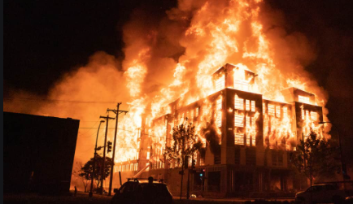 | Why do people call this a miracle?
 | Do you think it’s a miracle? Explain your answer.
A very poor person wins the lottery. | Why do people call this a miracle?
 | Do you think it’s a miracle? Explain your answer.
Modern Science | Why do people call this a miracle?
 | Do you think it’s a miracle? Explain your answer.
The Natural World | Why do people call this a miracle?
 | Do you think it’s a miracle? Explain your answer.

