Tuesday 23rd June
Here is today’s ditty to read together
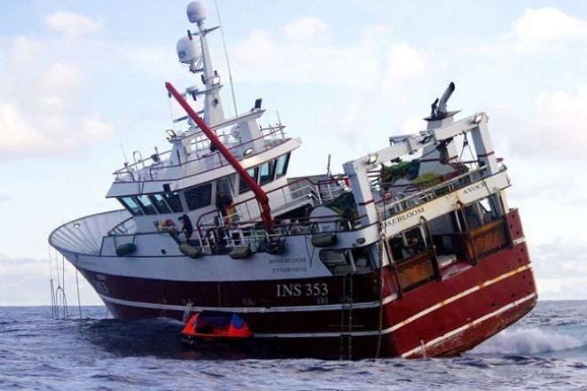
Tricky words: catch mackerel
This is my boat.
I go out to get fish.
I catch them in a big net.
I might catch a cod or a mackerel.
Do you like fish?
Hold a sentence: I get fish in a net.
Extension sentence: I like cod and chips!

Let’s recap some of our red words

Who all when the

here they come she

came said he this

her for were was

