Activities for KS2
Be a detective and go on an angle hunt in your house and garden. What angles can you spot.  Challenge: Take accurate measurements of these angles.  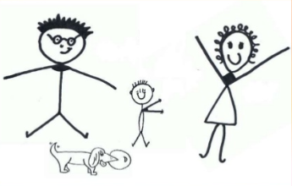 | With the help of an adult, make a cake or biscuits. Your job is to measure out the ingredients, reading the scales carefully. | Create a bar chart or pie chart of your family and friend’s favourite foods, sports or even animals. You could phone family members who do not live with you to gather more information.  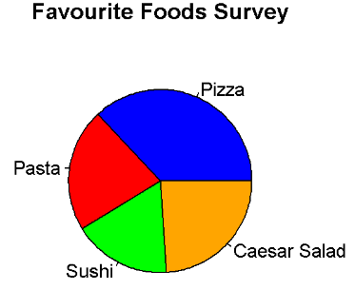 | Create a maths poster on any topic you like. This could be fractions, times tables, division – whatever you choose. Remember to include some fun facts and pictures.  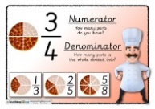
Measure and compare the perimeter of the rooms in your house.  Challenge: Work out the area of one of these rooms. | Create your own Mondrian piece of art work. What will you use to draw the lines? Label some lines that are horizontal, vertical, perpendicular and parallel.  https://www.tate.org.uk/art/artists/piet-mondrian-1651 | Look for patterns in nature. Describe the patterns. Do they tessellate? How often do they repeat? Can you create your own pattern based on what you have seen?  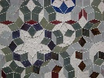 | Use old plastic bottles to make skittles. Write a single digit number on each skittle. How many can you knock over with one go? Add up your score and multiply this by 10.  Challenge: Try calculating your average score.  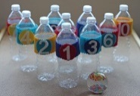
Design your own maths game and play this with your family.  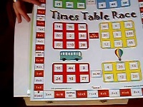 | Create a maths rap and perform this. Alternatively, you could use TT Rockstars to learn a times tables song to perform. Channel your inner popstar! | Create a maths quiz – write at least 10 questions down (remember, you must know the answers to these). Be the quiz master and play this with your friends and family. Who wins? | Choose five numbers. How many different calculations can you create using these numbers?

