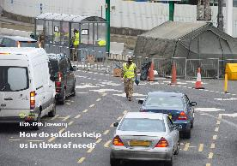 

Design a combat uniform for a soldier.

Soldiers have to keep themselves very fit. Create a fitness session. Think about the equipment you need, the space you have, how long the session will last and how you can make your fitness session easier or harder depending on who is doing it!

Soldiers usually wear a camouflaged uniform when in combat. This is so they can remain hidden. Some animals rely on camouflage. Can you name any of these animals and find out more about them? You could draw a picture of one or create a fact file?

Read and research to find out more about soldiers in the past. Perhaps you could look at a period in history such as WWI or WWII?

Use ‘Home resource 1’ to organise some marching soldiers into arrays. How many columns, rows and soldiers do you have? Can you record a number sentence?

Plan and write a letter to a soldier. This could be someone you know or you could find the nearest base to send the letters. Think about:

* Why are you writing? To thank them for their work? To find out more about their role?
* Share some information you know about how soldiers have been helping recently.
* Ask any questions you have or share what you would like to know.

**Learning from home**

Use the ideas below, alongside this week’s resource, to support your home learning.