30.3.20 Year 5 and 6 Writing Task

Discovery of the door

It was fantastic Friday, my favourite day of the week and I had just arrived back at home after a long day of school. I was about to pull my favourite, chocolate Snicker bar out of the full, kitchen cupboard when my mum appeared, “Please Lily, go and get changed because I don`t want chocolate on that clean white top!” she called. I yawned and slumped up-stairs.
When I got there, I fell on top of the bed and looked up at the ceiling. I could hear my little brother, Angus introducing his new, stuffed gorilla to all the other plump, button-eyed teddies in his typical, seven-year-old bedroom, which was cluttered with all sorts of shabby books and long-broken Lego models. I couldn`t find one of my old dark t-shirts I so went to ask if he had folded one away by mistake but when I got there he just shooed me out and told me that he was in a private meeting which was for toys and boys only.
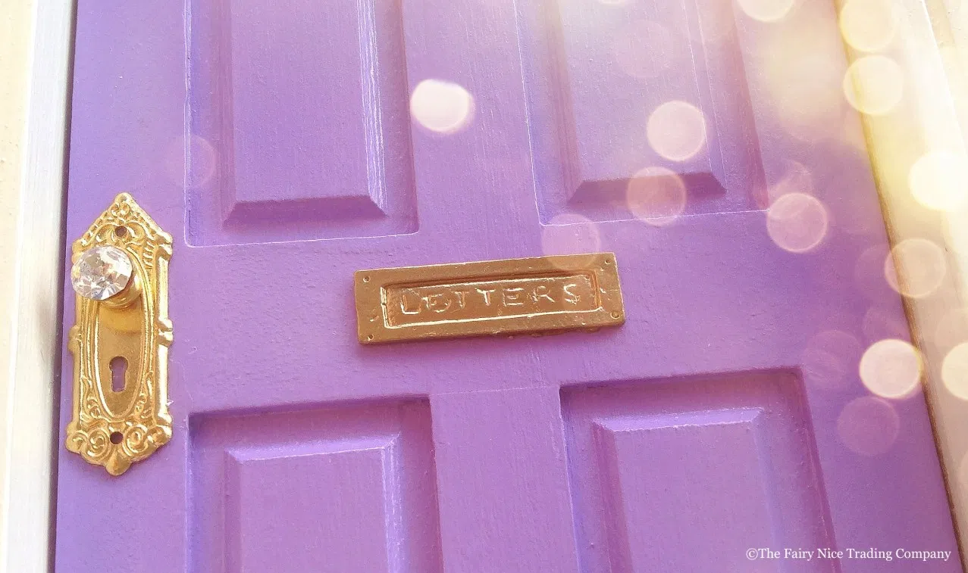
As I returned to my room, I noticed a small, purple door with a letter tucked though the old, dented letter box. I nervously pulled out the letter and…

THE room fell into DARKNESS!

I realised that my eyes were shut so I quickly opened them and looked around. I could tell that I was in my room, but everything was different, different as in smaller. Then I realised that I had shrunk!
Suddenly, I heard small, squeaky voices coming closer and closer until someone or something prodded me on the back. “Ouch!” I screamed, it hurt a lot! When I turned around, a funny, old man was looking at me with a cheeky, little grin that reached his watery, grey eyes. They looked like they could pop out of his pale, wrinkly face at any moment. “Look!” he cried, “The young girl that lived here has finally noticed the door! She took the letter from the letter box and now she has shrunk like I did!”
“W..w.. what d.. do you mean?” I stuttered. The old man yelled in my face one more time, “I used to live here! Then found the door and shrunk like you! I’ve been living in your doll’s house ever since!” Then he spoke quieter, “But I’ve always been too scared to go through the door.”
With that, I burst open the door and ran through it, but this was a mistake…
“AAAAAAAaaaaaahhhhhhhhhhaaaaaahhhhhhhh!” I screamed.
The door led to the edge of a cliff and I was falling fast! Suddenly I landed on a soft bed of flowers. I looked around and saw a busy little town, all lit up in the dark. So, I got up to explore. First, I noticed a shop with a sign in the window `Sweets for Everyone`. With that, I ran to the amazing store, plonked a Snicker bar on the counter and asked the funny, little elf at the counter, “How much?” The elf looked at me as if I was stupid and laughed, “It’s totally free here!” he yelled.
I took the free Snicker bar and ran off into the night. I ate it and savoured every bite, closing my eyes as the caramel and nuts melted in my mouth.
When I opened them, I was me-sized again and back in my own room!
Now I go there all the time and I have even made friends with the shrunken, old man. But does he live alone? Well that’s another story…

