Curriculum Information
Beech
Summer Term 2020
Produced by:
Mrs S. Young

susan.young1@school360.co.uk

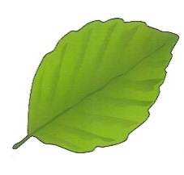

Awesome Alnwick
We have planned this topic as if we were going to be in the classroom, however, this will be adapted for home learning on a week by week basis.
Our topics for this term are…

Awesome Alnwick

Geography - Children will find out about the location of Alnwick within Britain and use aerial photos and maps to describe its features. We will learn about the four countries of the UK and their capital cities.

Alnwick Castle and Harry Hotspur

History - Children will learn about the passing of time by looking at timelines of their own family events. They will find out about how castles were developed and then they will find out about the special history of our local castle and Harry Hotspur.

Living Things

Science - Children will compare the differences between things that are living, dead and have never been alive. They will find out about the habitats of animals as well as their basic needs.

Natural Sculptures
Art – The artist Andy Goldsworthy will provide a stimulus for making sculptures out of natural materials.

Castles
DT – The children will design and make models of castles.

On-Screen Programming
Computing - Children will apply their knowledge of programming floor robots to control on-screen sprites.

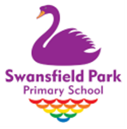

Other subjects:

P.E. Cricket and athletics

P.S.H.E. Relationships

Music Friendship Song

R.E. Special events and promises Jews make to God

English:
English involves the development of speaking and listening, reading fluency, comprehension and writing skills. Children will have many opportunities to develop their reading and comprehension skills both in the classroom and during weekly guided reading sessions. They will also be able to apply their skills across other areas of the curriculum during their topic work. Over the course of the year, children will experience a range of narrative, non-fiction and poetry texts.
This half term, we intend to explore stories, poems and non-fiction texts. Children are welcome to bring in books related to the topic.
You can find specific objectives for the term on your class page of the school website.

Mathematics:
In KS1, our aim is to ensure that pupils develop confidence and mental fluency with number, counting and place value. Our learning begins in a very practical way before moving to more formal methods. Children will also explore shapes, measurements, position and direction.
The children’s ability to ‘reason’ will be developed throughout all of their mathematical work as they are encouraged to explain how they have reached solutions to problems.
This half term, we will be focusing on fractions, statistics, properties of shapes, measurement, position and movement, telling the time.
You can find specific objectives for the term on your class page of the school website.

Homework & Spellings
Weekly Tasks: Please check our weekly blog on the Beech Class page on the school website to see the planned home learning for each week.
Reading: Please ensure your child reads as often as possible.
Other ways of helping your child:
- Using the Internet to research our topic.
- Discussing what is being taught.
- Playing English and Maths games on our virtual learning environment at www.school360.co.uk (please note that Frog Play will no longer be available from 1st May, however games will still be available and accessed in the same way. I’ll update you when I find out more about its replacement)
- Times Table Rockstars
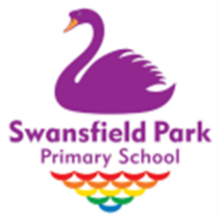
- Numbots
- Keep an illustrated diary of your days at home

