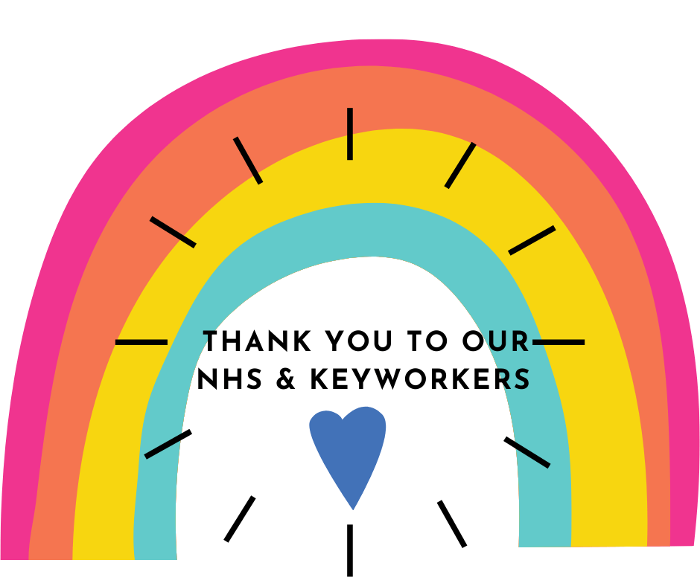

Swansfield Park Primary School Art Competition
Hi everyone,
With our annual art competition, Alnwick in Bloom, being cancelled until next year, I thought we might have our own school competition to keep us busy over what would be May Half Term. The images above and below will give you a big clue as to what I have in mind! I would like you to get creative and design a picture which celebrates not just our fantastic NHS but all keyworkers too who are working so hard to help us all at this time. You can use any medias you have to hand: watercolours, crayons, pencils, poster paints, felt pens, gel pens – the choice is yours. You can also create your design on paper or card of any size and it doesn’t need to be fancy! If you don’t have card or paper to hand then perhaps you can recycle something such as the inside of a cereal box. Below is a choice of different categories which any age can enter however you will see that certain categories are best suited to certain ages. Choose one then start planning some ideas for your art work.
Once you have created your final masterpiece, take a photo of it and email it to myself at michelle.smith@swansfield.northumberland.sch.uk
Make sure I know your name and class too. Judges will choose 3 winning pieces of art work for Nursery, Reception, Key Stage One as well as Lower and Upper Key Stage Two. Local artist, Katherine Renton, who is normally on the judging panel for Alnwick in Bloom, will be helping with the judging process. She is very much looking forward to seeing the art work you send in and as well as helping select the winners. She will be sharing her thoughts on the winning pieces of art work too.
PLEASE ENTER ONE OF THE FOLLOWING CATEGORIES:
Category 1: Over the rainbow
Rainbows are a popular theme at this time. Get creative and design a piece of art work which thanks keyworkers with a rainbow. You might use your finger tips or handprints to paint a rainbow or you could use chalks, pens etc. You could create a different shape but in rainbow colours or draw the area you live in with a rainbow overhead. Some of these images might inspire you or you may have a brilliant idea of your own!
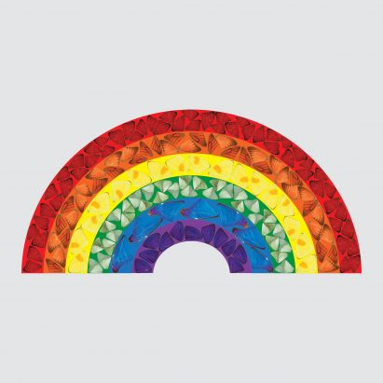
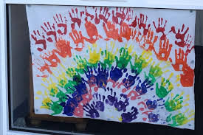
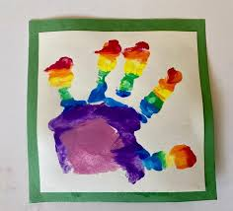
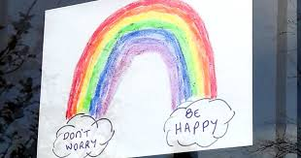

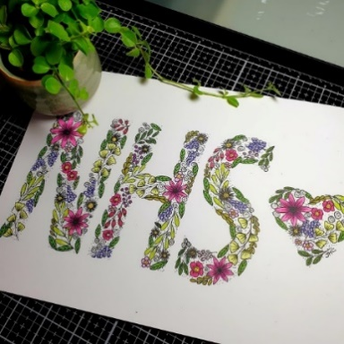
Category 2: Say it with flowers!
Bringing in a bit of the ‘Alnwick in Bloom’ theme, some of you might want to design a thank you message to keyworkers or just the NHS and fill the message with a flower design. It doesn’t have to be just flowers; it could be filled with a ‘nature’ theme. Think of what nature means to you and have a go or go ‘flower power’!

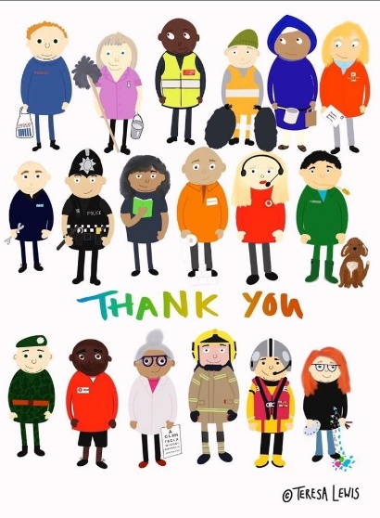
Category 3: Paint a key worker.
Think about some of the key workers who are still working hard and helping us in our everyday lives right now. Why not paint one? This key worker poster might inspire you. You could draw or paint one key worker or have a go at drawing several. It’s up to you!

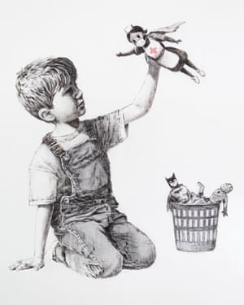
Category 4: Create your own keyworker ‘Banksy’
Banksy is an anonymous England – based street artist who has recently created this piece of artwork which at the minute is displayed in Southampton General Hospital until the autumn when it will be auctioned to raise money for the NHS. As you can see, the image depicts a young boy who has discarded his usual superhero toys in favour of this one dressed as an NHS nurse. This category asks you to draw yourself or maybe a brother, sister or cousin playing with a new keyworker superhero. We don’t expect this detail but put your artistic skills to the test and have fun!

Please have your finished piece of art work, along with your name and class emailed to myself by Wednesday 3rd of June. Winners will be announced on Monday June 15th along with Mrs Smith’s weekly blog and prizes will be organised in due course.
Have fun, get creative and be part of the big ‘thank you’ to all our superhero keyworkers!

Michelle Smith

