Name:......................................... Date:.........................................

Divide these Sweets into 2 equal groups:

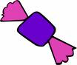
__ ÷ __ =

Divide these bananas into 2 equal groups:
__ ÷ __ =
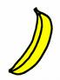

Divide these cakes into 2 equal groups:
__ ÷ __ =

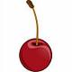

Divide these cherries into 2 equal groups:
__ ÷ __ =

Divide these sandwiches into 2 equal groups:

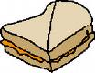

16 ÷ 2 =

Divide these sweets into 2 equal groups:
__ ÷ __ =

Divide these cherries into 2 equal groups:

__ ÷ __ =

Challenge:
Emma has 12 chocolate bars. She decides to share them equally between 2 friends. How many chocolate bars does each friend get? Draw the groups:

...............................................................................................................................................................................................
Becky has 8 boxes of coloured pencils. There are 2 coloured pencils in each box. How many coloured pencils does Becky have altogether? Draw the groups:

Now draw your own grouping and write the number sentence:

