Monday 22nd June
Sound Time
Are you ready to hit those sounds? This week we are going to focus on the different ways of making:
ow

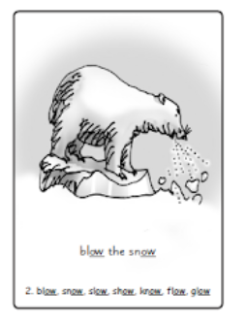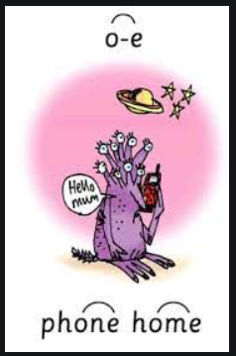
Now read the words:
blow snow show know
slow window shadow glowing
home hope spoke note phone
note broke rope bone stone
Can you find more “ow” and “o_e” words?

Ditty Time!
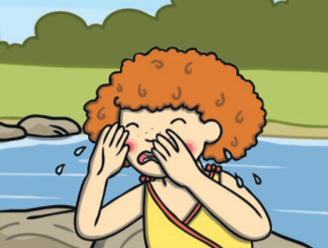
Katie Morag woke up at home and looked out of her window. She spoke in a low voice and said: “I hope it does not snow today.

As she drove slowly over to meet the boat she did not know that she was too low in the water.

She froze when she saw the yellow boat then she fell in and hoped she had not broken her elbow on a stone.

Hold a sentence:
Mum likes to joke in the roses at home.
The king broke his low throne.

