15Th May 2017
We are learning to predict and record the weather

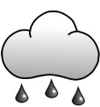
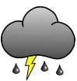
Forecast for this week
Monday | Tuesday | Wednesday | Thursday | Friday

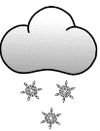
Weather this week
Monday | Tuesday | Wednesday | Thursday | Friday

Was your forecast correct? ______________________________
___________________________________________________
How many days were sunny? ______________________________
How many days were rainy? ______________________________
How many days were cloudy? _____________________________

