Maths Key Skills Stage 4: Skill Check 9

Name: ___________________________________ Date: _______________ Class/Group: _______________________________

A: Place Value, Add and Subtract |  | B: Multiply, Divide and Fractions |  |  | C: Measure and Geometry
1. What is the missing number?  50 75 100 150 | 4:1 | 11. 84 ÷ 12 = |  | 4:9 | 21. Which of these is the best estimate for the weight of a packet of crisps?  a. 2 grams b. 20 grams c. 200 grams |  | 4:21
2. What is the missing number?  54 72 81 90 | 4:1 | 12. Use 3 x 7 x 11 = 231 to answer:  21 x 11 |  | 4:10 |  |  | 4:21
3. What is 1,000 less than 2,934? | 4:2 | 13. 64 x 8 = |  | 4:11 | 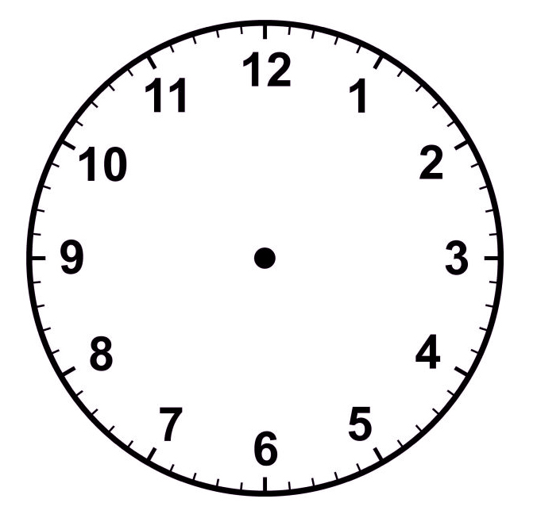  22. Draw the hands  to show:  19:05 |  | 4:22
4. Round this number to the nearest 1,000: 3,275 | 4:2 | 14. Shop A sells 6 pens for £3.60. Shop B sells 2 pens for £1. Which is cheaper? |  | 4:12 |  |  | 4:22
5. Put these numbers in order, smallest first: -1 -5 -3 | 4:3 | 15.  1  3  6  3  1  100  =  = |  | 4:13 | 23. What is the name of this quadrilateral? |  | 4:23
6. Put these in order, smallest first:  2,395 2,593 2,359 | 4:4 | 16. I have of a cake. How many hundredths do I need to make ?  1  10 |  | 4:14 |  |  | 4:23
7. What number does this Roman Numeral represent? LXXV | 4:5 | 17.  9  5  2  5  36  100  - |  | 4:15 | 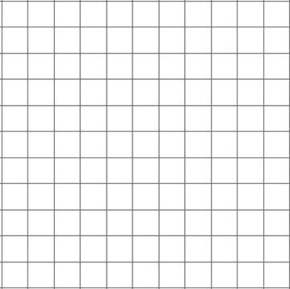  24. Plot the point (5, 2). Label it C.  1 2 3 4 5 x  y  5  4  3  2  1  0  A  B  25. Points A, B and C form 3 corners of a square. Plot the fourth corner of the square and label it D. |  | 4:28  4:28
8. 3,473 - 1,230 = | 4:6 | 18. Write as a decimal number. |  | 4:16 |  |  | 4:28  4:28
9. Write the sum to check 392 - 98 = 294: 98 + = | 4:7 | 19. What is the value of the 1 in:  3.91 |  | 4:17 |  |  | 4:28  4:28
10. Pencils weigh 55g. Pens weigh 73g. How heavy are 2 pencils and 1 pen? | 4:8 | 20. Round 3.6 to the nearest whole number. |  | 4:18 |  |  | 4:28  4:28
Total (A) |  | Total (B) |  |  | Total (C)
Test Total (A+B+C) |  | R (0-9) | Y (10-19) |  |  | G (20-25)

