Maths Key Skills Stage 2: Skill Check 9

Name: ___________________________________ Date: _______________ Class/Group: _______________________________

A: Place Value, Add and Subtract |  | B: Multiply, Divide and Fractions |  |  | C: Measure and Geometry
1. What is the missing number?  36 46 56 66 76 | 2:1 | 11. 7 x 5 = |  | 2:11 | 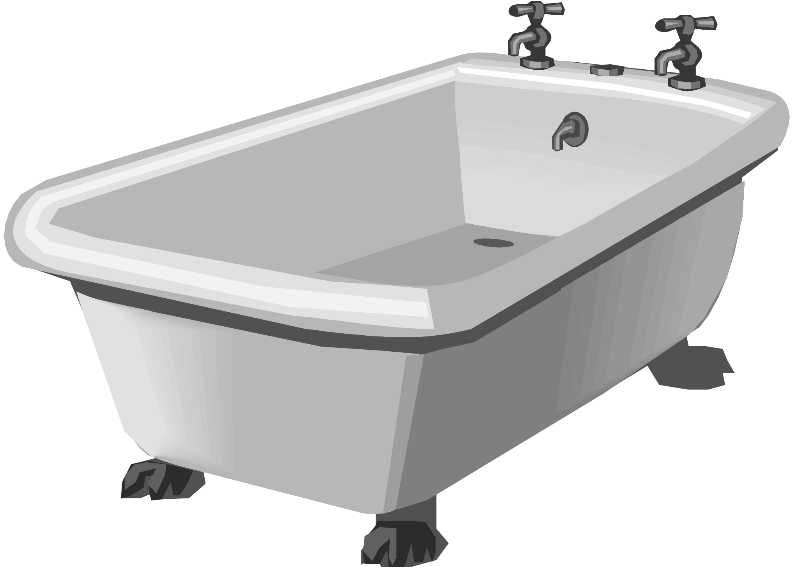  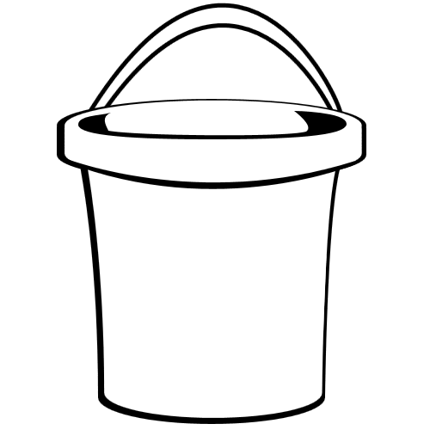  21. Which of these has the smallest capacity?  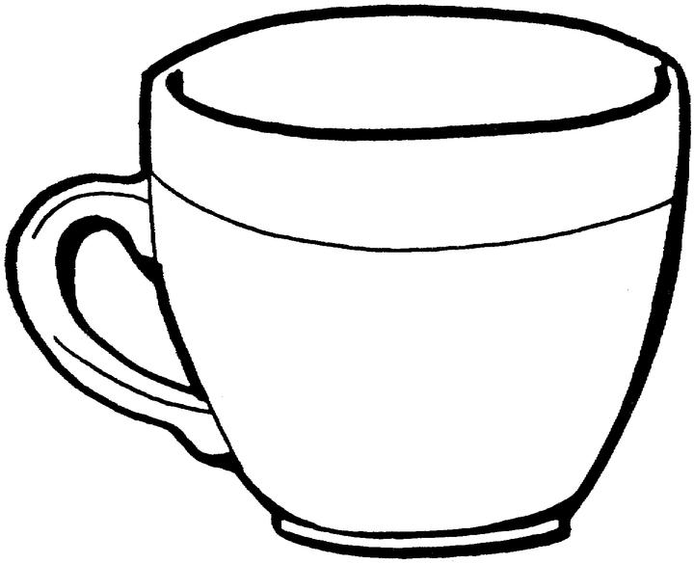  a. a bath  b. a bucket  c. a cup |  | 2:18
2. Circle the 3s that have a value of 30.  13 38 43 31 | 2:2 | 12. Which are the odd numbers?  7 14 21 28 |  | 2:11 |  |  | 2:18
3. What number is labelled?  5  10 | 2:3 | 13. What symbol is missing?  6 x 3 18 |  | 2:12 | 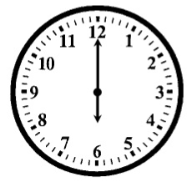  22. How many hours are there in 1 day?  a. 12  b. 24  c. 60 |  | 2:21
4. Put these in order, smallest first.  65 6 5 56 | 2:4 | 14. What symbol is missing?  20 5 = 4 |  | 2:12 |  |  | 2:21
5. Write this number in words.  84 | 2:5 | 15. Is this true? Write ‘yes’ or ‘no’.  18 ÷ 6 = 6 ÷ 18 |  | 2:13 | 23. Which of these shapes has 3 sides?  a. triangle  b. circle  c. square |  | 2:23
6. A garden has 8 trees. 6 more are planted. How many trees now? | 2:6 | 16. 6 flowers each have 4 petals. How many petals are there in total? |  | 2:14 |  |  | 2:23
7. Use 8 + 12 = 20 to answer:  24 + = 60 | 2:7 | 17. I have 24 eggs. If they come in boxes of 6, how many boxes do I have? |  | 2:14 | 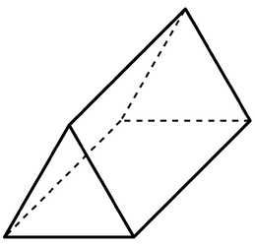  24. Complete the sentence:  A triangular prism has 5  a. vertices  b. edges  c. faces |  | 2:24
8. 4 + 8 + 7 = | 2:8 | 18. What fraction of the  strawberries is circled? |  | 2:15 |  |  | 2:24
9. Tick (✓) if true:  62 + 9 = 9 + 62 42 - 9 = 9 - 42 | 2:9 | 19. Write the fraction two thirds in numerals.  1  4 |  | 2:15 | 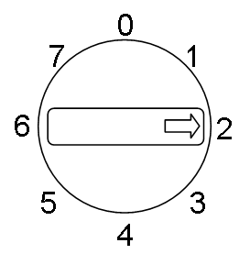  25. This dial is pointing  at 2. What number will  it point to after being  turned clockwise  through 1 right angle? |  | 2:28
10. Use 46 - 13 = 33 to help find:  33 + 13 = | 2:10 | 20. What is of 16 ? |  | 2:16 |  |  | 2:28
Total (A) |  | Total (B) |  |  | Total (C)
Test Total (A+B+C) |  | R (0-9) | Y (10-19) |  |  | G (20-25)

