Cherry Class Blog 14
Bonjour Cherries, hope you are all well. Great feedback from last week I know a lot of you enjoyed the objects in the bag and it was a real winner. I love how some of you used the bag every day and mixed it up. Well done!
I thought this week I would put a few little things on the blog to help our children get school ready as a lot of our Cherries would be in the full swing of transition if they were in their classroom with me and Jenny, so I wanted to give you parents some top tips to start drip feeding your children about coming back to school - whether it be for Cherry Class or getting ready for nursey. It is so important for our little ones to feel safe and secure in new settings with new practitioners, and given the circumstances it’s even more important when the time comes that you as parents feel ready and you feel confident your child will be ready for a smooth transition.
Transition can take different amounts of time to get used to for different children so let’s begin to get school ready at home!
Why not create an All about me poster – this could have a picture of your child on or a family picture, how old they are, talk to your child about what they like to do, discuss who lives at home, what’s your child’s favourite book, food, toys, favourite colour, animal, places to visit – celebrate your child – don’t be afraid to put in things that scare them, what they don’t like etc. This activity will help children use their personal, social and emotional skills as well as helping new staff understand a little bit more about your child at home. The more info the better! When finished you could display it in your home and refer to it every so often when talking about school such as: “mmm I wonder what new toys there will be at school? You might have some new favourite toys” Take a picture and feel free to send it to me and it can be uploaded to their journal so their new teacher can access it. You can do your in whatever way your child would like - draw, paint, cut things out and stick etc. Good luck.
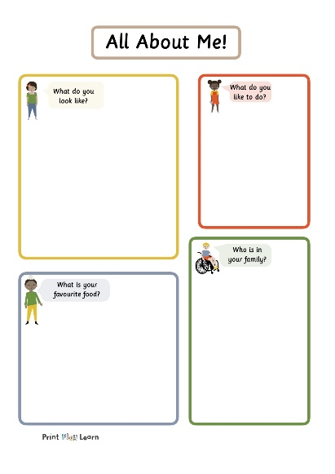
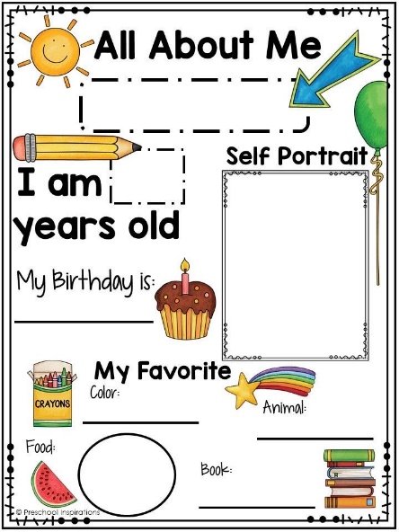

Another way to help our children is to read stories – there are lots of stories out there to do with starting school, I will attach a picture below with some story books to read.
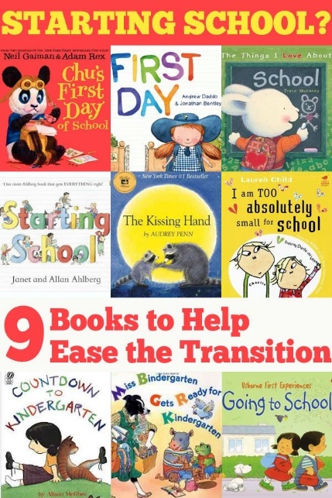

When the time comes, it can be a confusing, fun, worrying, scary, exciting time for our little ones and we want to make sure they are able to communicate their feelings during this time and for that matter any other time. They also need to be able to communicate feelings and needs to new staff (I know a lot of parents have this worry), so let’s get our children communicating! You can do this in many ways at home by simply talking about it or using props, you find this works better as it is more informal for children. It so important for us as practitioners to understand how the children feel and why they are feeling a certain way. This can be done using a feelings table, station or wheel. You can set this up at home and use it as much or as little as you like. It could be something to refer to when managing feelings and behaviour at home. Again this will help your child’s personal, social and emotional development at home and school.
Top tip: don’t forget you can use the feelings station after reading one of the story books above or talking to your child about starting a new class or (pre)school.
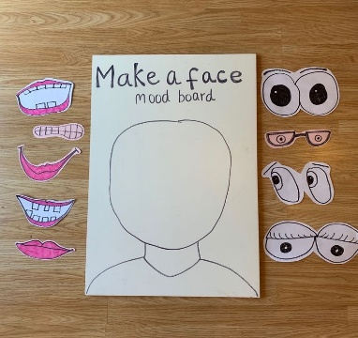
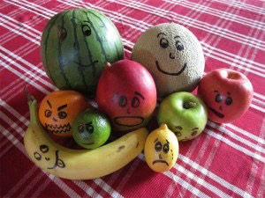
Here are some examples below.

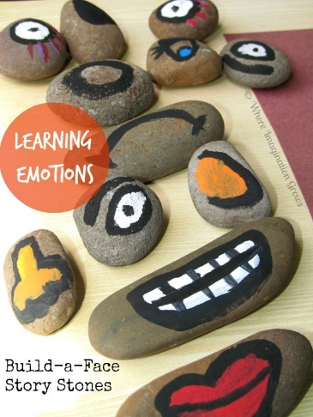
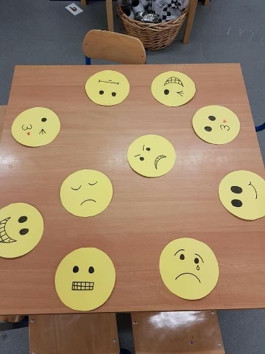

Quick and short activities you could do to help with transitioning:
- Trying on school uniform or looking at it.
- Looking at the school website (new class, and staff, pictures)
- Helping mum/dad shop for some school shoes.
- Drawing pictures of your new school and classroom.
- Talk about your new teachers’ names Cherry – Claire and Jenny, Apple Miss Freeman and Kerry.
- Talk about the friends who will be in the same class as your child and meeting new friends.
- Practise a walk past the school (don’t forget your 2 metres distance!)
- Role play teachers using yourselves or props.
I hope this helps Cherry families! Good luck!

This week’s activities:
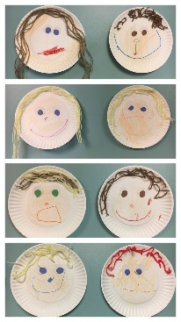
Monday: Draw a portrait or help make your child’s face you can use paper, paper plate, use a mirror, look at details of the face and talk about what we need to make a face.

Tuesday: Make up a story there is no right or wrong. Parents, you can write what your child says. Let your child be experimental with words and sounds. Write what your child says and when finished read the story back to your child. This can be super fun and funny.
Wednesday: Make a puppet show, use teddies, make your own puppets and have fun!
Thursday: Paint stones – paint patterns or faces on your stones and create your own patterns or use your stones for your feelings station.
Friday: Looking at family photo of parents/carers when they were young children and memories – talking about starting school, sports days at school, assemblies, fun days out and celebrating your family.
All the above activities support children’s personal, social and emotional development and learning skills such as empathy, understanding, talking, communicating, self-awareness, making relationships, feelings, emotions, language, behaviour, self-confidence etc.
Have a good week Cherries stay safe Claire

