Practically share 6 cubes onto two plates.  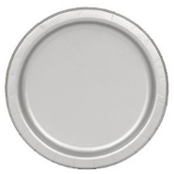  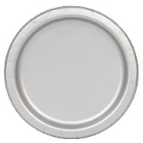 | There are ___ cubes altogether.  There are ___ two plates.  There are ___ cubes on each plate.
Practically share 10 cubes onto two plates. | There are ___ cubes altogether.  There are ___ two plates.  There are ___ cubes on each plate.
Practically share 6 cubes onto three plates. | There are ___ cubes altogether.  There are ___ two plates.  There are ___ cubes on each plate.

Share 8 beanbags between the 2 hoops.  8 ÷ 2 = __ | 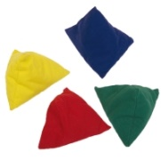
Share 12 beanbags between the 3 hoops.

12 ÷ 2 = __

Share 8 beanbags between the 4 hoops.

8 ÷ 4 = __

Jane has 10 sweets and shares them between 2 friends.
Tom has 10 sweets and shares them between 5 friends.
Draw pictures to show whose friends will receive the most sweets and write the calculations to match.

