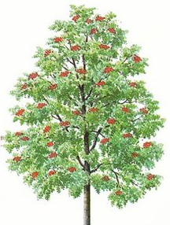
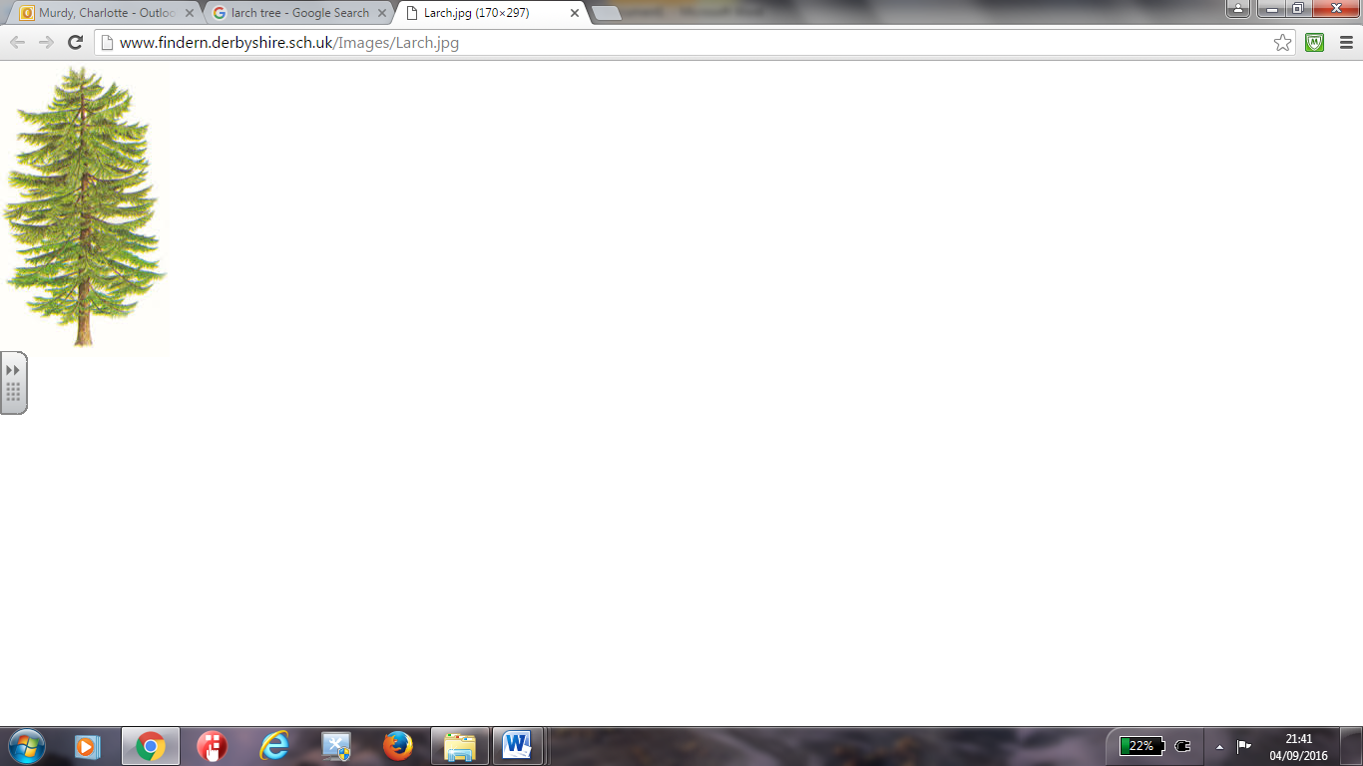
Curriculum Information
Sycamore, Rowan and Larch
November - December 2019
Produced by:
Mrs C. Murdy, Miss C. Back, Mrs E. Rutherford and Mrs J. O’Connell
www.swansfield.northumberland.sch.uk

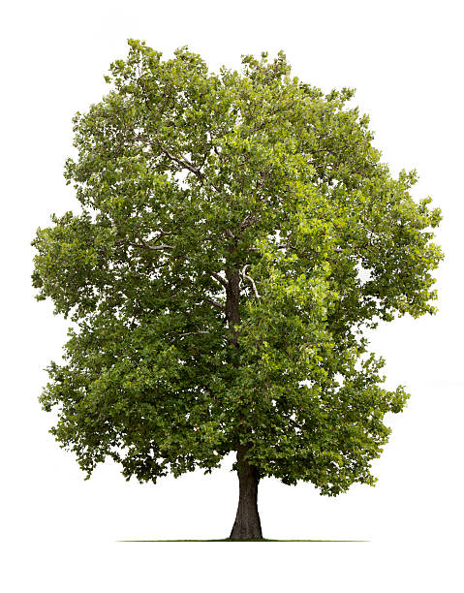

Our topic for this half term is Time Travellers: Marvellous Mayans

This includes:
Geography - Central America: Exploring Mesoamerica
Children will begin by locating Mesoamerica on a world map, identifying the modern countries and cities that are now located where the Mayans lived. They will then use a variety of sources of information, including graphs, to explore the physical geography of Mesoamerica. Using ‘street view’ functions on online maps, they will explore the area and identify features. To finish, the children will investigate what life is like for modern Mayans by exploring how it is similar to or different from the life of Mayans in the 1st century, using photographs and other sources of information to find out facts.

History - Mayan Civilisation: Conquest of the Aztecs
The children will begin by finding out about the Spanish conquistadors and their expeditions in Mesoamerica, looking at some of the Mayan temple ruins and generating questions that the conquistadors may have asked, as well as questions they would like to find the answers to themselves. Children will move on to learn what an archaeologist does and how artefacts can help us find out about the Mayan civilisation. Using their mathematical skills, the children will order important events from The Mayan civilisation chronologically. Moving on the children will begin to think about how our society is run and who makes our decisions before comparing this with how Mayan society was structured. The children will find out about different groups of Mayan people from kings and nobles to slaves and farmers, as well as how Mayans lived in various independent city states. Children will investigate Mayan beliefs and Gods and how this affected their daily lives and what the Gods demanded from the Mayan people. Children will move on to generating questions about the everyday lives of ordinary Mayans and using a variety of different sources of information to find answers to their questions, presenting their findings in a variety of ways. Children will learn about some of the major achievements of the Maya, specifically their writing and number systems, and the development of calendars. They will consider the importance of writing from the Mayans in helping historians find out about the past. Children will then finish by looking at evidence from battles between city states and consider some of the reasons for the decline of the Mayan civilisation and what could have caused Mayans to abandon their major cities, discovering that the Mayans didn’t disappear completely and that smaller pockets of Mayan people still live in the area today.

Art - Mayan Masks: The funerary mask of Lord Pakal
Children will investigate and recreate Mayan masks by exploring the mask of Lord Pakal. They will investigate other uses for Mayan masks before progressing to use a variety of techniques, including papier máché, to design and create their own.

Computing - Creating Adobe Spark Videos
The children will begin by logging into the online software system and investigating the different templates available before selecting an appropriate one. They will then move on to creating their Adobe Spark videos by inserting videos, pictures and altering size and position. They will finish by reordering their slides, recording a narration for their video and inserting music. Their videos will then be shared with peers and constructive criticism given to help identify strengths and areas for further development.

Other subjects:

P.E. Swimming (Tues) and Basketball (Fri) French Christmas Vocabulary
P.S.H.E. Healthy Lifestyles and Relationships Music Classroom Jazz
R.E. Christianity: Is the Christmas Story True? Pupil Parliament Bill of Rights

Please also use the school website to keep up to date with your child’s learning. Teachers regularly update their class pages with photographs and important information for parent.

English: - Instructions and Explanations (Ancient Sports Academy)

- Information Texts (The History Detective Investigates: Mayan Civilization)
- Historical Fiction (Treasure Island - Robert Louis Stevenson)
English involves the development of speaking and listening, drama, reading, comprehension, grammar and writing skills. Children will have a variety of opportunities to develop and demonstrate mastery within their reading and comprehension both in the classroom and during weekly guided reading sessions. They will also be able to apply their skills across other areas of the curriculum during their topic work.
During their English lessons, children will be working from cross curricular units of work, each of which will last between 2-4 weeks. Each term, children will experience a range of narrative, non-fiction and poetry.

Mathematics: Multiplication & Division, Area & Perimeter, Fractions and Geometry

Children will develop and demonstrate mastery in their knowledge, skills and understanding of number, fractions and geometry this half term.

They will multiply and divide whole numbers by 10, 100 and 1000 whilst identifying multiples and factors, this including all factor pairs of a number and common factors of two numbers. Children will recognise square numbers and cube numbers, using the notation for squared (²) and cubed (³) as well as use the vocabulary of prime numbers, prime factors and composite (non-prime) numbers. Children will then be able to establish whether a number up to 100 is prime and recall prime numbers up to 19.

When learning about the area and perimeter of shapes, children will measure the perimeter of composite rectilinear shapes in cm and m and calculate and compare the area of rectangles, including using standard units, cm², m². Children will also develop an understanding of estimating the area of irregular shapes.

When learning about fractions, children will use common factors to simplify fractions and use common multiples to express fractions in the same denomination. They will compare and order fractions, including fractions > 1 and generate and describe linear number sequences (with fractions). Children will learn to add and subtract fractions with different denominations and mixed numbers, using the concept of equivalent fractions to do this. Children will multiply simple pairs of proper fractions, writing the answer in its simplest form. As they continue to calculate with fractions, they will divide proper fractions by whole numbers and begin to associate a fraction with division. Finally, children will recall and use equivalences between simple fractions, decimals and percentages, including in different contexts

The children’s ability to ‘reason’ will be developed throughout all of their mathematical work as they are continuously encouraged to explain, justify and deepen their thinking

Homework & Spellings:
Weekly Tasks: Every Monday, your child will be set two homework tasks: one English and one Maths. They will have until the following Monday to complete them. Their homework tasks may be written comprehension, punctuation and grammar, written pieces or online tasks from School 360. They will be based upon what they have been learning in class in order to consolidate their new knowledge, skills and understanding. Details of weekly homework tasks can be found in children’s planners as well as on the school website within your child’s class page.
Spellings: Spellings will be set and tested each Monday.
Mental Maths: J2Blast on School360 and Times Tables Rockstars should be used at home by the children on a weekly basis to develop their fluency and times tables skills. Children have their own usernames and passwords for accessing both programmes. Metal maths skills will be tested on a weekly basis.
Reading: Guided Reading will take place on a weekly basis. **Please ensure that both yourself and your child comment regularly in the reading record. Also, it is important that your child reads a range of literature (magazines, books, newspapers) for at least one hour per week so please encourage them to use both the school library and local library.
Planners: Children have their own planners to record homework, PE days and important dates. We ask that you sign their planner every week, it is also available to communicate with your child’s teacher.
Pencil cases: We would like to encourage all children to have a pencil case at school. As a minimum, each child’s pencil case should contain: two black biro pens, a pencil and sharpener, a ruler and a rubber, this being in preparation for High School.
PE Kits: Children must have their PE Kit in school every Friday along with appropriate footwear. The school’s expectations of these kits can be found in your child’s planner on Page 5. Where children are not able to participate in their allocated PE lesson, they will join another KS2 class and be given work to complete.
Wellies and outdoor shoes: Please ensure that your child has a pair of named wellies or outdoor shoes available in school at all times for playtime as well as outdoor learning activities.

