Bullet Train Times - Minutes To
What times are the trains due? Write the time in words.
1.
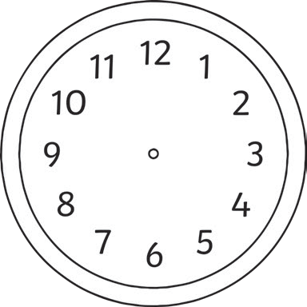
55 60 5
50 10

45 15
2.
55 60 5
50 10

45 15
3.
55 60 5
50 10

45 15
4.
55 60 5
50 10

45 15

40 20
35 30 25
40 20
35 30 25
40 20
35 30 25
40 20
35 30 25

minutes to 3 minutes to 4 minutes to 5 minutes to 4

5.
55 60 5
50 10

45 15
6.
55 60 5
50 10

45 15
7.
55 60 5
50 10

45 15
8.
55 60 5
50 10

45 15

40 20
35 30 25
40 20
35 30 25
40 20
35 30 25
40 20
35 30 25

Draw the hands on these clocks to show the exact time (don’t forget the minute hand is the big one and the hour hand is the small one!)
9. 10.

14 minutes to 3

11. 12.
7 minutes to 7
21 minutes to 9

18 minutes to 4

Bullet Train Times - Minutes To
What times are the trains due? Write the time in words.

1.
55 60 5
50 10

45 15
2.
55 60 5
50 10

45 15
3.
55 60 5
50 10

45 15
4.
55 60 5
50 10

45 15

40 20
35 30 25
40 20
35 30 25
40 20
35 30 25
40 20
35 30 25

5.
55 60 5
50 10

45 15
6.
55 60 5
50 10

45 15
7.
55 60 5
50 10

45 15
8.
55 60 5
50 10

45 15

40 20
35 30 25
40 20
35 30 25
40 20
35 30 25
40 20
35 30 25

Draw the hands on these clocks to show the exact time (don’t forget the minute hand is the big one and the hour hand is the small one!)
9. 10.

14 minutes to 3

11. 12.
7 minutes to 7
21 minutes to 9

18 minutes to 4

Bullet Train Times - Minutes To
What times are the trains due? Write the time in words.

1.
55 60 5
50 10

45 15
2.
55 60 5
50 10

45 15
3.
55 60 5
50 10

45 15
4.
55 60 5
50 10

45 15

40 20
35 30 25
40 20
35 30 25
40 20
35 30 25
40 20
35 30 25

5.
55 60 5
50 10

45 15
6.
55 60 5
50 10

45 15
7.
55 60 5
50 10

45 15
8.
55 60 5
50 10

45 15

40 20
35 30 25
40 20
35 30 25
40 20
35 30 25
40 20
35 30 25

Draw the hands on these clocks to show the exact time (don’t forget the minute hand is the big one and the hour hand is the small one!)
9.
10.
11.
12.
12 minutes to 4 19 minutes to 8 14 minutes to 5 17 minutes to 9

13.

14.

A train was supposed to arrive at 18 minutes to 5, but was delayed by 13 minutes. Draw on the hands to show when it will arrive.

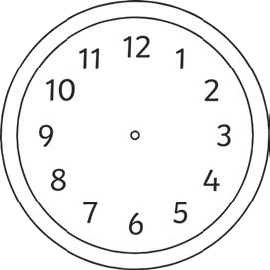
Another train was supposed to arrive at 27 minutes to 3, but was delayed by 7 minutes. Draw on the hands to show when it will arrive.

