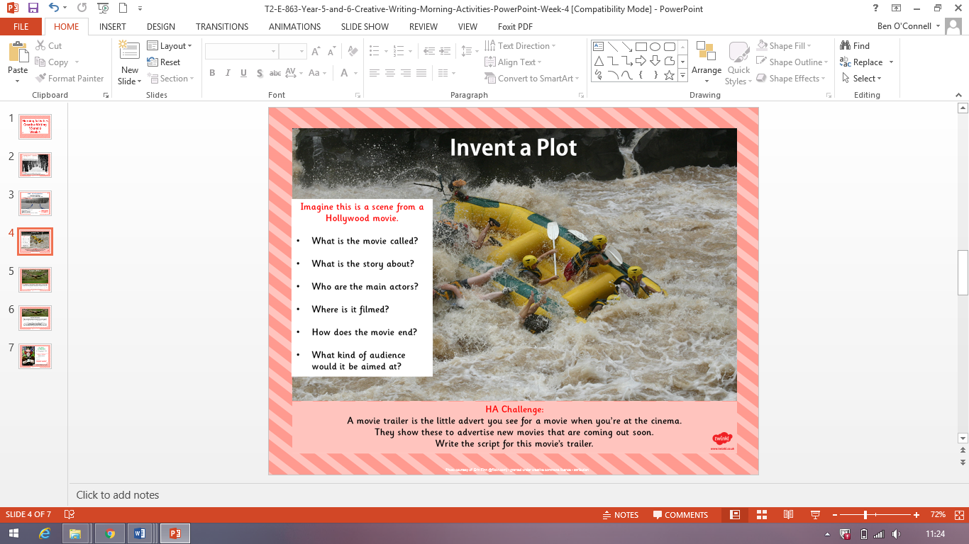

This task is optional but you are very welcome to complete it as well, if you wish!