Monday 22nd^{th} June
Here is today’s ditty to read together but 1st look at the sound recap on page 2.
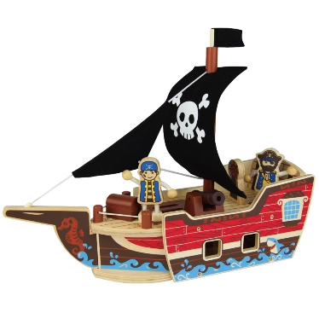
Tricky words: bones know made

This is my boat.
It is made of wood and it has a flag.
The flag has a skull and cross bones.
My boat has a plank.
Do you know who has to go on the plank?

Hold a sentence: It has got a flag.
Extension sentence: Go along the plank.

Let’s look at ow and oa
They are both in our ditty today

know boat flow goat

slow moan throw road

show grow throat foal

