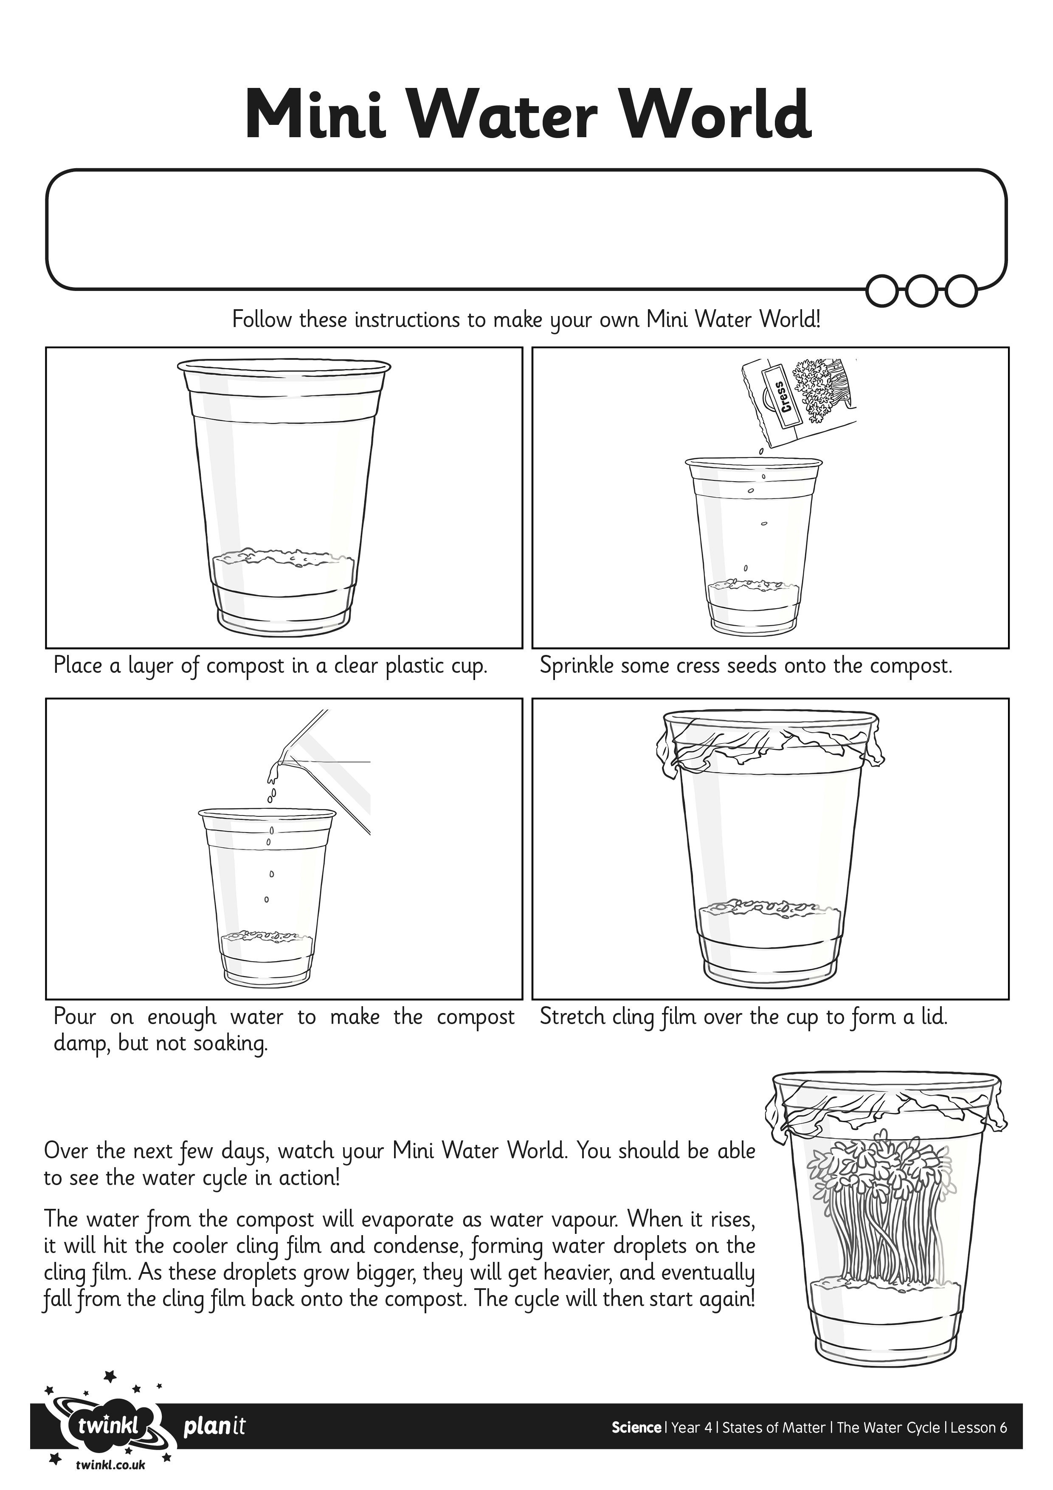
I can explain how a model of the water cycle demonstrates the different stages.

