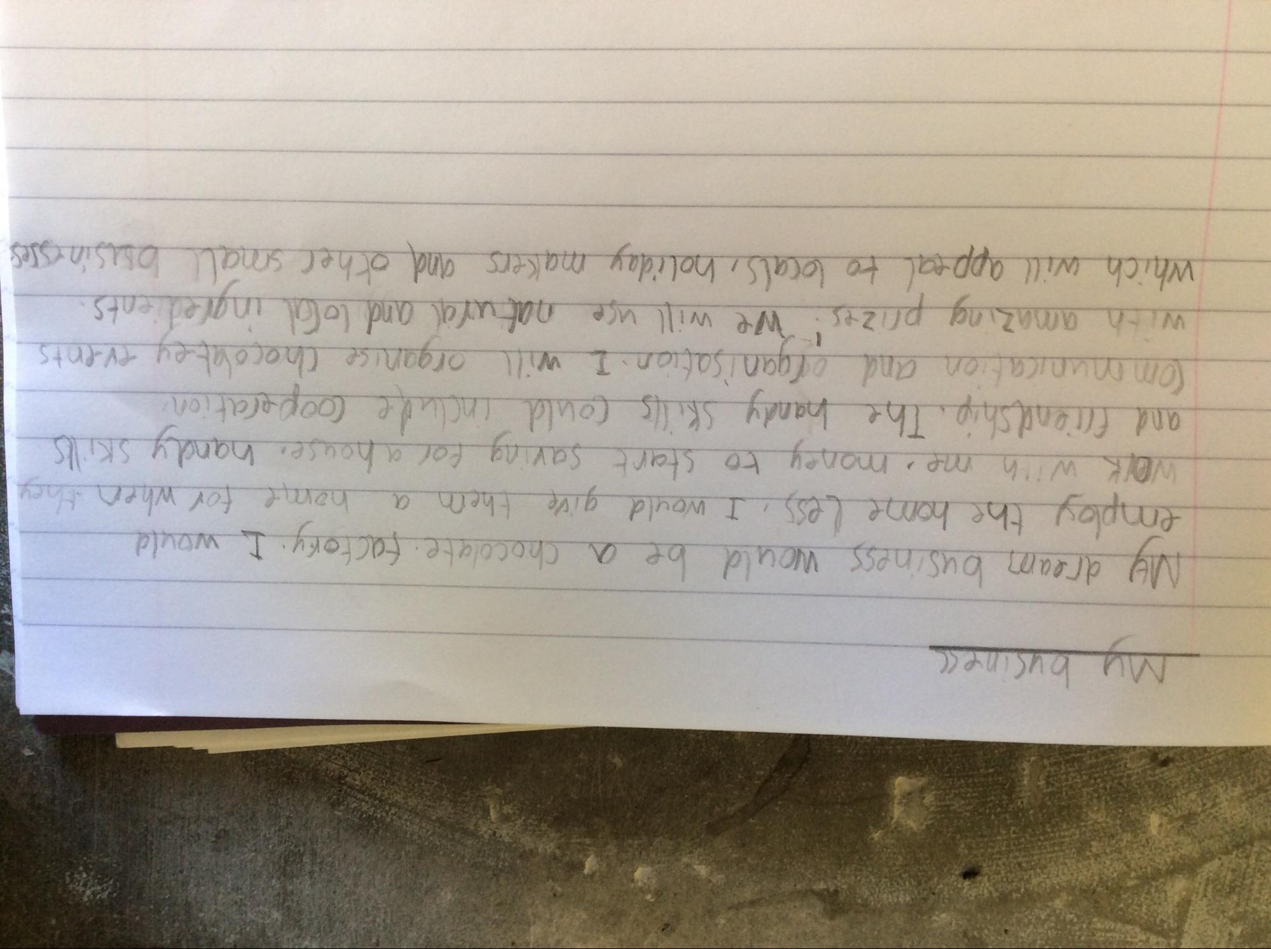
My businec
My dream business would be a chocolate factory. I would
employ the home less. I would give them a home for when they Walk with me. money to start saving for a house, handy skills and friendship. The handy Skills could include cooperation Communication and organisation. I will organise chocolatey events with amazing prizes. We will use natural and local ingredients. which will appeal to locals, holiday makers and other small businesses

