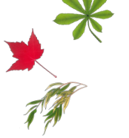
Curriculum Information
Willow, Chestnut and Maple
Autumn Term (2) 2022
Produced by:
Mrs M Smith, Miss E Langman, Mr C Warburton, Mrs J O’Connell and Miss T Thompson
www.swansfieldpark.northumberland.sch.uk

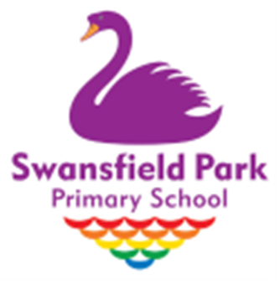

Our learning for this term is

Time Travellers – Romans

This includes:

English – Across the Roman Wall by Theresa Breslin
Our work over this half term will centre around the historical fiction, ‘Across the Roman Wall’ by Theresa Breslin. We will be exploring plot and character as well as generating our own Roman-inspired creative writing. During this book study, we will be developing various reading strategies such as questioning, prediction, inference and visualisation. Our spelling, punctuation and grammar objectives will be taught within the context of the book and our non-fiction work will complement our learning in history lessons.

Mathematics
Children will continue to develop their knowledge, skills and understanding within key areas in Mathematics following the White Rose Hub scheme of work. In this term, children will focus on addition and subtraction, measurement, multiplication and division. The children’s ability to ‘reason’ will be developed throughout all of their mathematical work as they are encouraged to explain how they have reached solutions to problems.

Humanities (History & Geography) – The Roman Empire and its Impact on Britain
Children will develop their skills as young historians through classroom questioning and by interpreting primary sources of historical evidence related to the Roman Empire and historical figures such as Emperor Claudius and Boudica. They will distinguish between historical evidence and legends and folklore in relation to historical figures such as King Arthur and Robin Hood. Amongst many other learning outcomes in this exciting topic, children will explore the design features of Hadrian’s wall and learn more about gladiatorial games. Classes will march their army outdoors to perform army drills including formations.

Design Technology – Roman Purses
Children will research the types of holders Romans used to carry coins and compare and contrast these designs to those of today. They will go on to generate ideas and sketches for a Roman coin purse then put their sewing skills into practise as they join textiles together and decorate their purse.

Science – Animals, including humans
The children will continue their learning for this unit and carry out a scientific enquiry. The children will find out that some types of food can damage our teeth and ways in which we can help look after them. They will learn that humans and animals have skeletons and muscles to support and protect their bodies as well as to help them move.

Other subjects:
P.E. Modified Games
Computing Creating a podcast
P.H.R.S.E.Celebrating Differences
MusicCharanga – Glockenspiel & Christmas around the World production
French Learn key greetings, colours and write a letter to Father Christmas (Autumn 2)
R.E. Christianity

Additional Information
Weekly Tasks (Homework):
Every Wednesday, your child will be set their homework tasks. They will have until the following Monday for some pieces of work and other tasks until the Wednesday to complete them. The details of the homework will be set on Google classroom.

Your child will be either sent some sheets home or they can access their homework online through Google Classroom. The tasks will be based upon what the children have been learning in class in order to consolidate their new knowledge, skills and understanding. If your child has any difficulties accessing their homework online, please contact either of us class teacher and alternative arrangements can be discussed.

Reading: Your child will need to have read in time for their weekly Guided Reading session. Please ensure that you and your child comment in their reading record on a regular basis. It is also important that your child reads a range of literature (magazines, books or newspapers) for at least one hour per week so please encourage them to use both the school library and local library.

Times Tables: Children are encouraged to log on to Times Tables Rock Stars every day. We recommend little and often is the best way to ensure your knowledge is secure. At parents’ consultations we shared that Year 4 children will be sitting the Multiplication Check in June therefore we recommend you practice against the clock. They have a username and password to log onto the website (https://play.ttrockstars.com/) to help them practise at home.

Arithmetic: We are focusing on our arithmetic skills this half term and to make sure the children are secure at knowing how to complete a variety of calculations. Your child will be sent some sheets of questions each week to help consolidate their learning.

Spellings: All of your child’s spellings will be set on Spelling Frame (https://spellingframe.co.uk/) every Wednesday and will be tested the following week.

A few reminders…

PE Kits: Children in LKS2 will have P.E on a Tuesday and Friday this term. Your child will need to come to school dressed in a school P.E kit on these days. PE kit is: a plain white t-shirt, a school jumper or school purple hoodie, purple shorts or black jogging trousers, and black or white trainers.

Water Bottles: Please ensure that your child brings a water bottle with them every day so that they can have a drink during the day.

Finally, a message from the LKS2 team: Welcome back to another busy half term! We have lots of lovely events happening in the next few weeks. We are really looking forward to welcoming you all to our Christmas production. Thank you for all your continued support, LKS2 Team

